

**LAB WORKBOOK**

**L537 – Implement Adobe Target for Optimal Performance**

Adobe Summit 2025

Lab Overview 1

Key Takeaways 2

Prerequisites 2

Part 1: Create On-Device Decisioning (ODD) activities in Target and save it to CDN experimentation property 2

Exercise 1: Create a CDN Experimentation Target property for optimizing the ODD rules package size (preconfigured) 3

Exercise 2: Log in to Adobe Target UI 6

Exercise 3: Create the test A/B activity in the CDN Experimentation workspace 7

Part 2: CDN edge-worker CLI and CDN Property configuration 11

Intro: CDN overview 12

Exercise 1: CDN CLI and CDN credentials 12

Step 1 [preconfigured on the lab machines]: Install Akamai CLI 12

Step 2: Verify Akamai CLI Installation - To ensure Akamai CLI is installed properly, run: 13

Step 3 [preconfigured on the lab machines]: Install Akamai CLI for EdgeWorkers - Assuming Akamai CLI is installed, run the following command to install EdgeWorkers: 13

Step 4: Verify EdgeWorkers Installation - To ensure EdgeWorkers is installed properly, run: 13

Step 5 [preconfigured on the lab machines]: Create an API Client 13

Step 6: Check Credentials 16

Exercise 2: CDN Property configuration (preconfigured for the lab) 17

Part 3: Coding with CDN Experimentation SDK 21

Exercise 1: Open the Lab Project in the IDE 22

Exercise 2: Creating the CDN Experimentation SDK Client Instance 24

Exercise 3: Retrieving the consequences 29

Exercise 4: Sending the Display event 30

Exercise 5: Working with the consequences 30

Appendix 34

## Lab Overview

In this lab you will learn a new implementation method for Adobe Target that will allow you to perform CDN experimentation. This new method will allow you to create A/B and XT Target activities and perform the decisioning work on your CDN for the fastest possible results.

## Key Takeaways

* Understand the different Target implementation methods and how using edge workers can lead to better performance
* Learn how to create a Target workspace and Property that can be used for CDN experimentation
* Using the Target Properties learn how to be selective about which activities are included in your rules bundle
* Get familiar with setting up the local environment for development
* Get familiar with how to configure an Akamai edge worker for Target experimentation
* Learn the basics of how to code in the CDN environment

## Prerequisites

* Adobe Target with product admin rights for editing workspaces and properties
* Access to your preferred CDN edge worker environment with the appropriate rights to configure settings
* Visual Studio Code software or another development environment of your choice

## Part 1: Create On-Device Decisioning (ODD) activities in Target and assign it to CDN experimentation property

**Section overview:** In this section, we'll start by reviewing the On-device decisioning features available in Adobe Target. Next, we'll create a CDN Experimentation Target Workspace in the Experience Cloud Admin Console. Then, using the provided lab user credentials, we will create an A/B Target test that will be applied on the lab test website. Intro: ODD in Adobe Target

* Enables near-zero latency content delivery by performing in-memory decisioning on the device it operates on.
* Caches A/B Test and Experience Targeting (XT) activity data
* Requires a rules artifact

### Exercise 1: Create a CDN Experimentation Target property for optimizing the ODD rules package size (preconfigured)

**Step 1 [preconfigured on the lab machines]:** Confirm the user Product Role for the workspace is set to Approver and Save

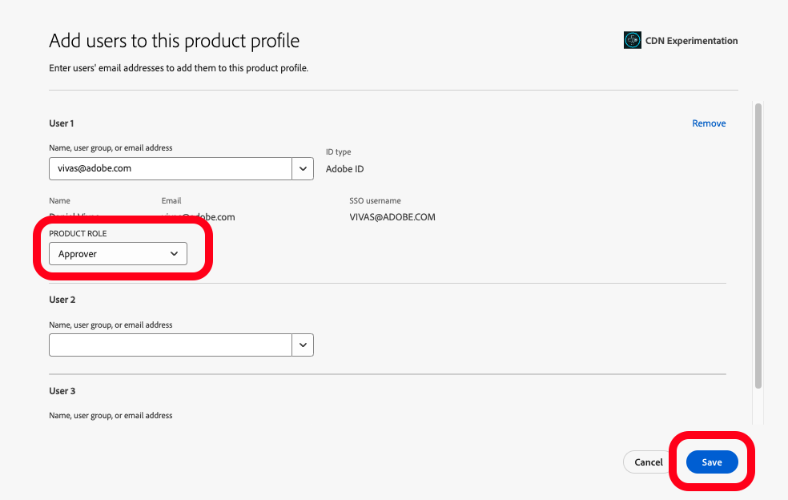

**Step 2 [preconfigured on the lab machines]:** In the Target UI navigate to the **Administration/Properties** section and click on Create Property button

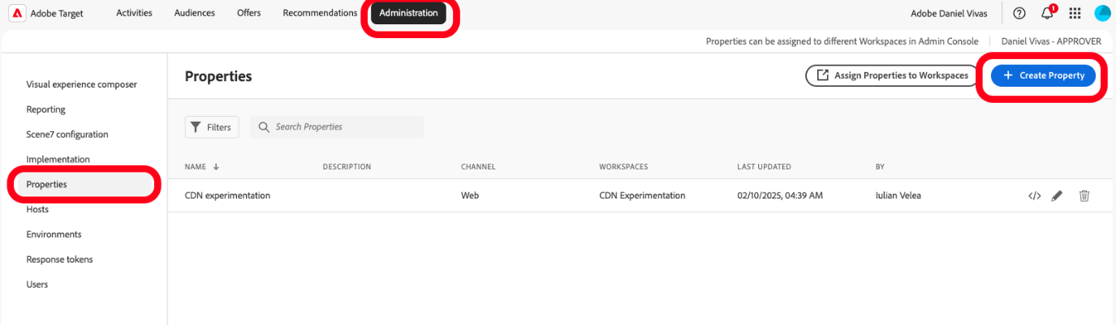

**Step 3 [preconfigured on the lab machines]:** Edit the properties details (your property will have the lab and seat number in the name e.g: L537+##) and click Save

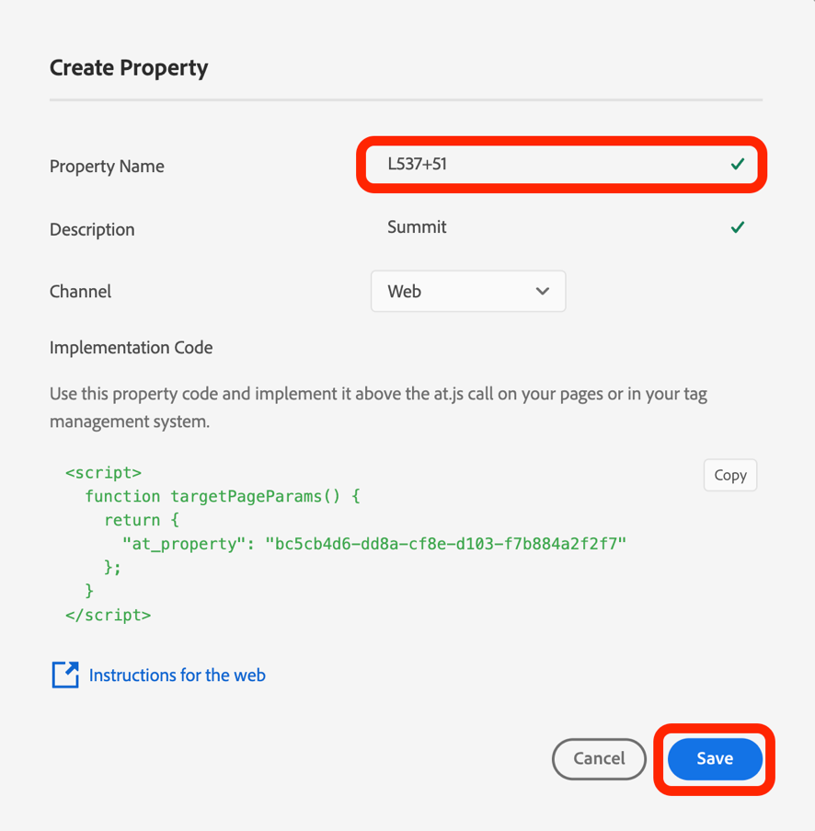

**Step 4 [preconfigured on the lab machines]:** Confirm the on-device decisioning setting is toggled on; this allows us to use the activities for On-Device Decisioning

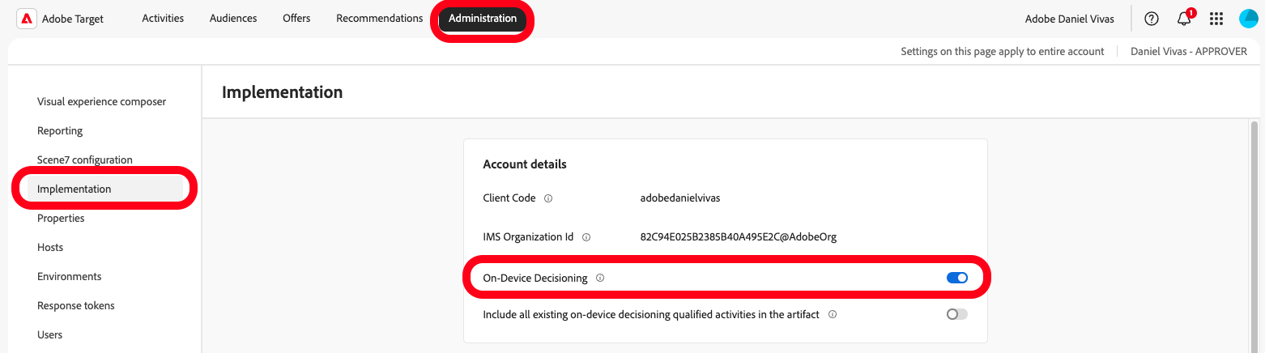

**Step 5 [preconfigured on the lab machines]:** Navigate back to the **Admin Console/Adobe Target/Default Workspace** profile settings and edit the Profile Permissions by clicking on the pencil icon next to “**Web”** under **“Permissions Access”**

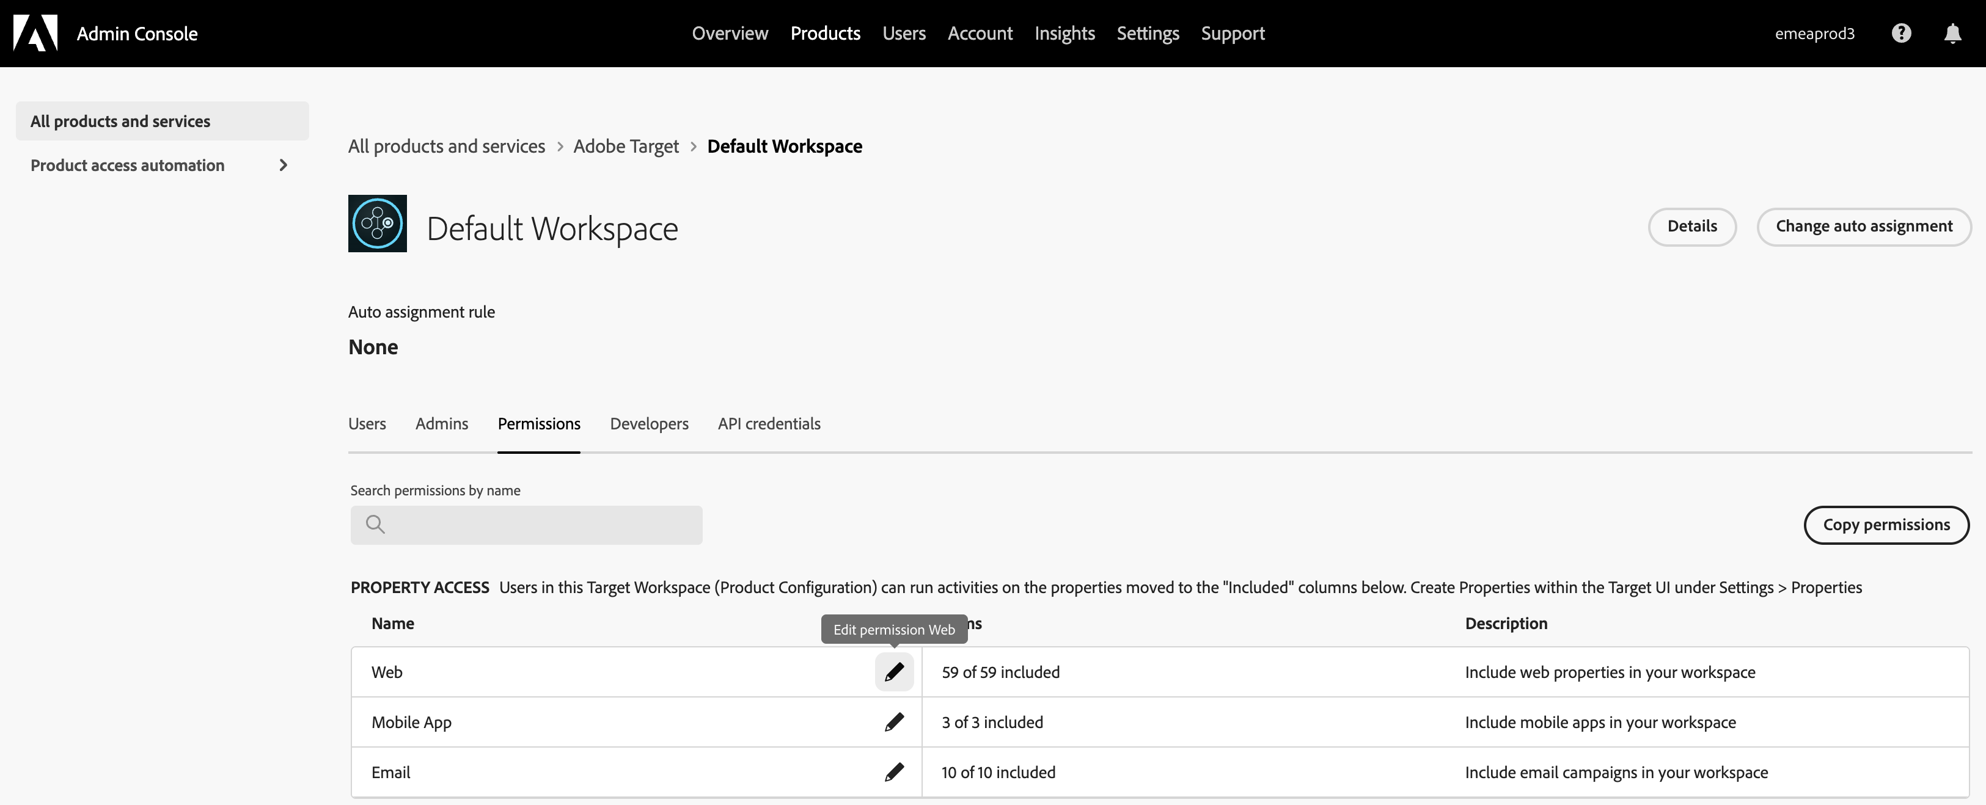

**Step 6 [preconfigured on the lab machines]:** Include the properties you will be using, in the permissions items by clicking on the “+” button and then **Save**

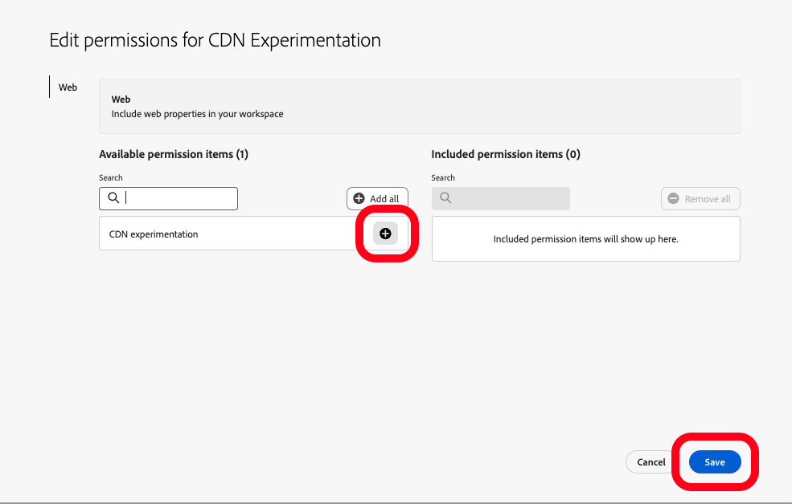

Exercise 2: Log in to Adobe Target UI

**Step 1:** Navigate to experience.adobe.com

**Step 2:** Enter the email address: [L537+##@adobeeventlab.com](mailto:L537+)

**Step 3:** Select “Company or School Account”

**Step 4:** Enter the password: Adobe4Summit!

**Step 5:** Select Adobe Target from the list of available solutions

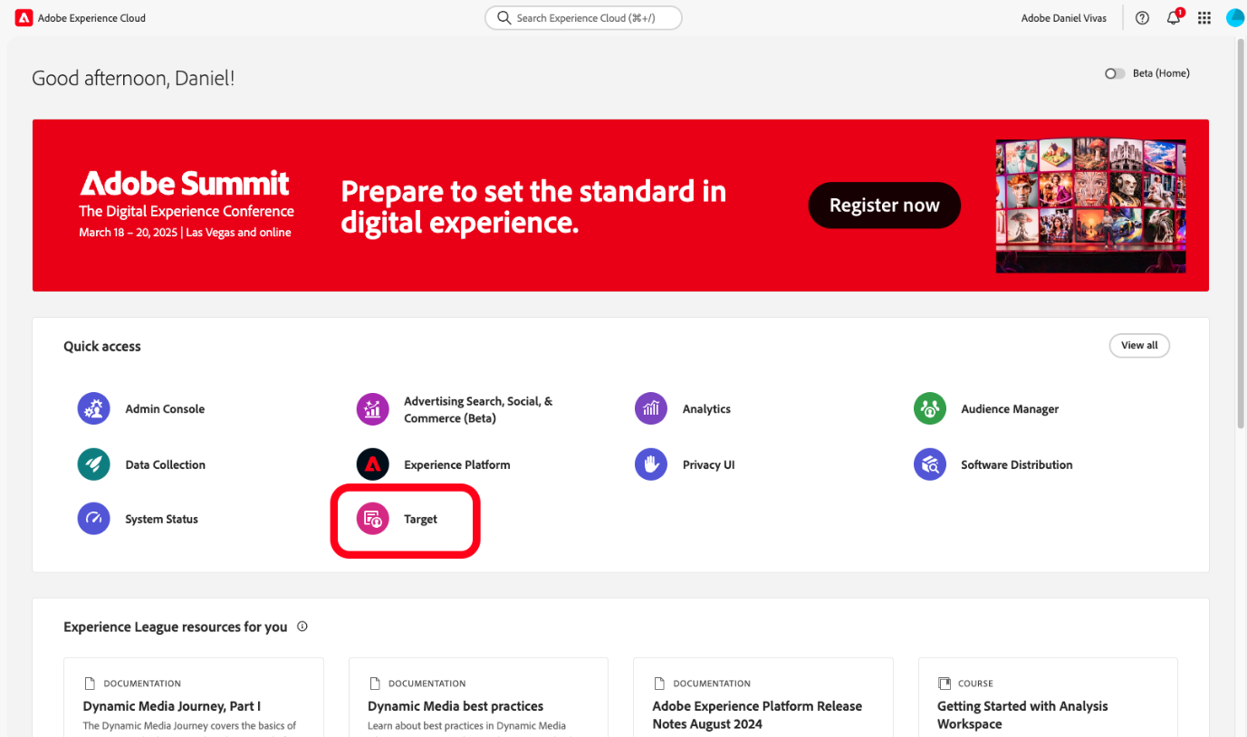

Exercise 3: Create the test A/B activity in the CDN Experimentation workspace

**Step 1:** Click on the Activities tab in the top horizontal navigation and identify the 'CDN Experimentation' activity that we have created in advance

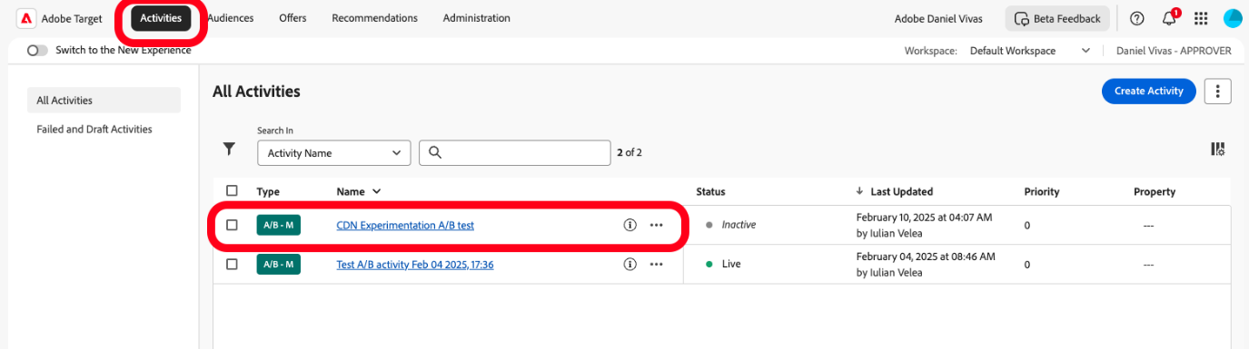

**Step 2:** Click on the ellipsis menu icon and select 'Copy' to duplicate the test activity

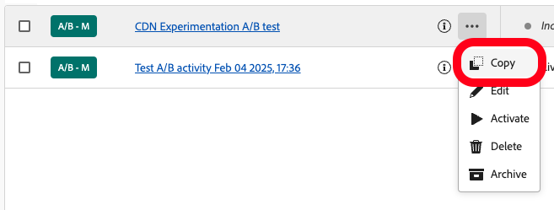

**Step 3:** Edit the activity name to include your seat number (ex: CDN Experimentation A/B test seat ##) and click save

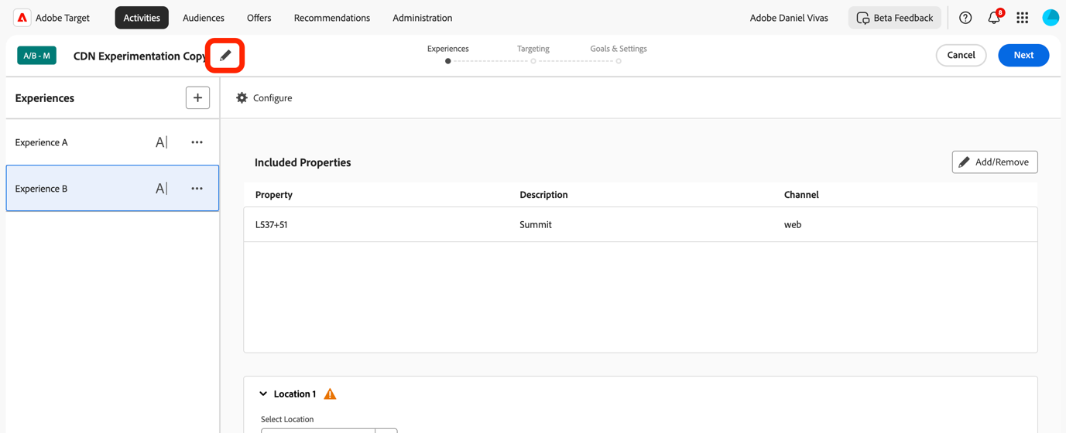

**Step 4:** From the activity editing page, in the Included Properties section click “Add/Remove” to add the corresponding property

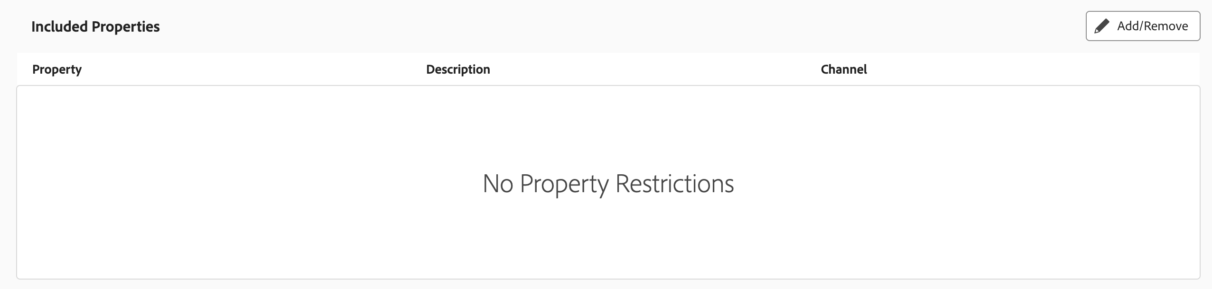

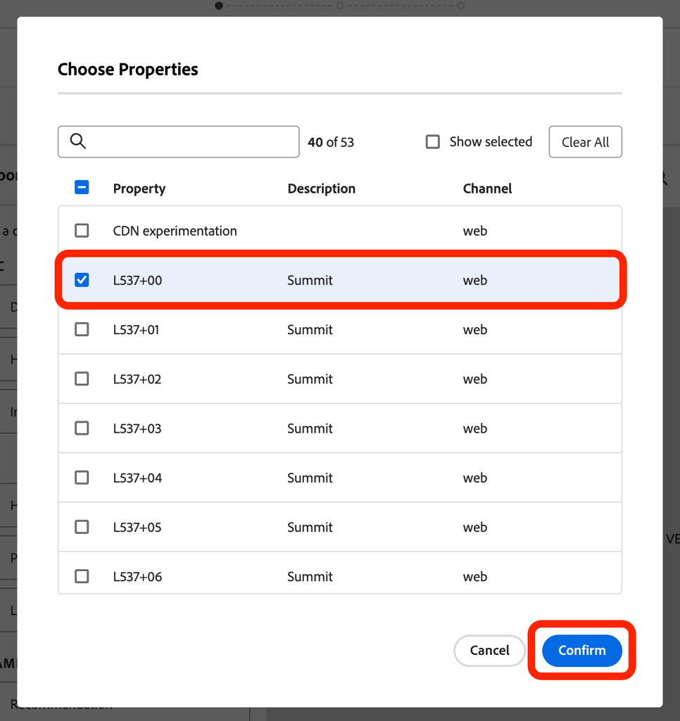

**Step 5:** Examine the changes being made to **Experience B** and click **Next**.

***Bonus step:*** Add additional changes to the experience that you would want to see in your final result (e.g. change the **h1** element text and/or text color)

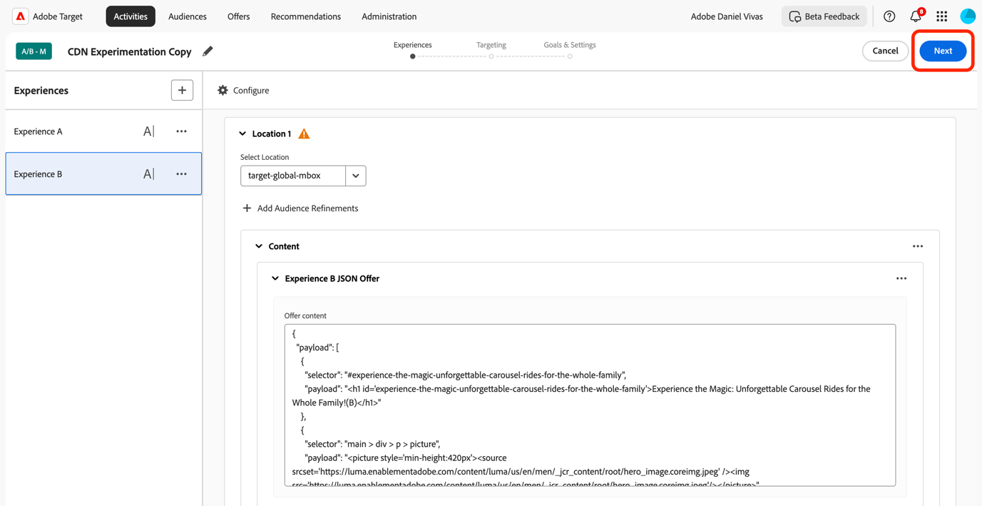

**Step 6:** Click **Next** on the “Targeting page”

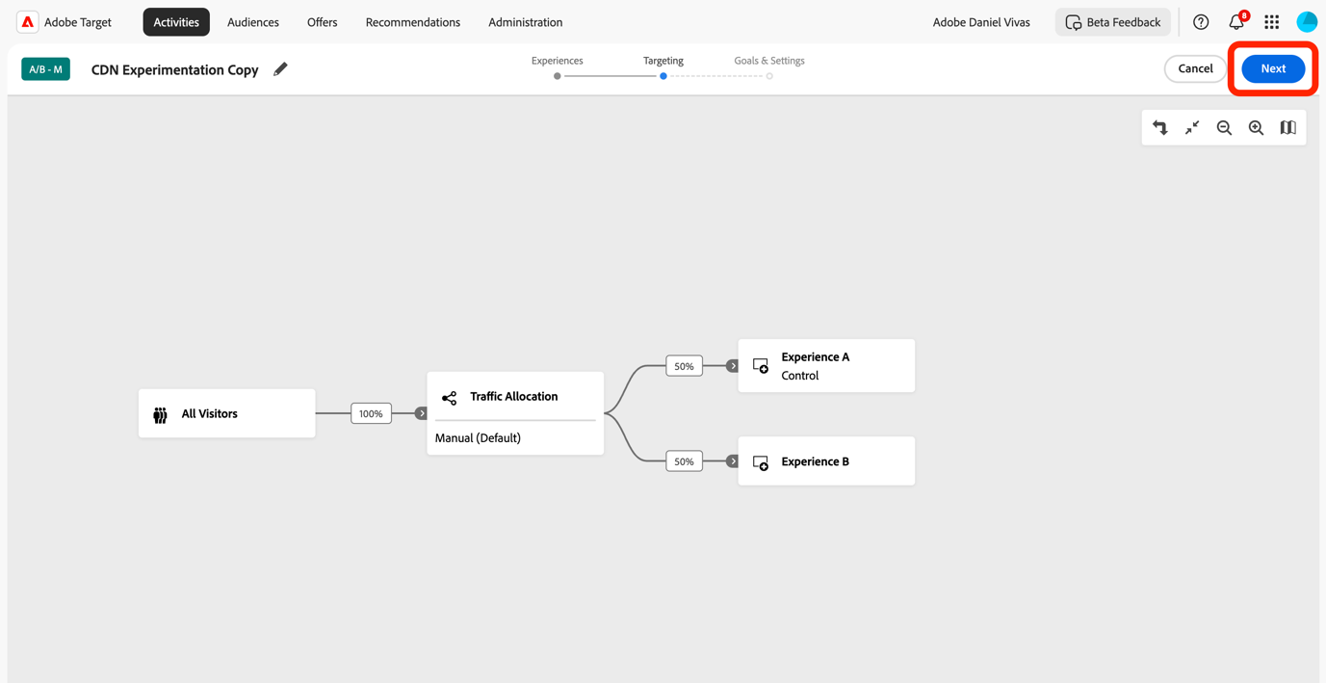

**Step 7:** Click **Save & Close** to finish the editing

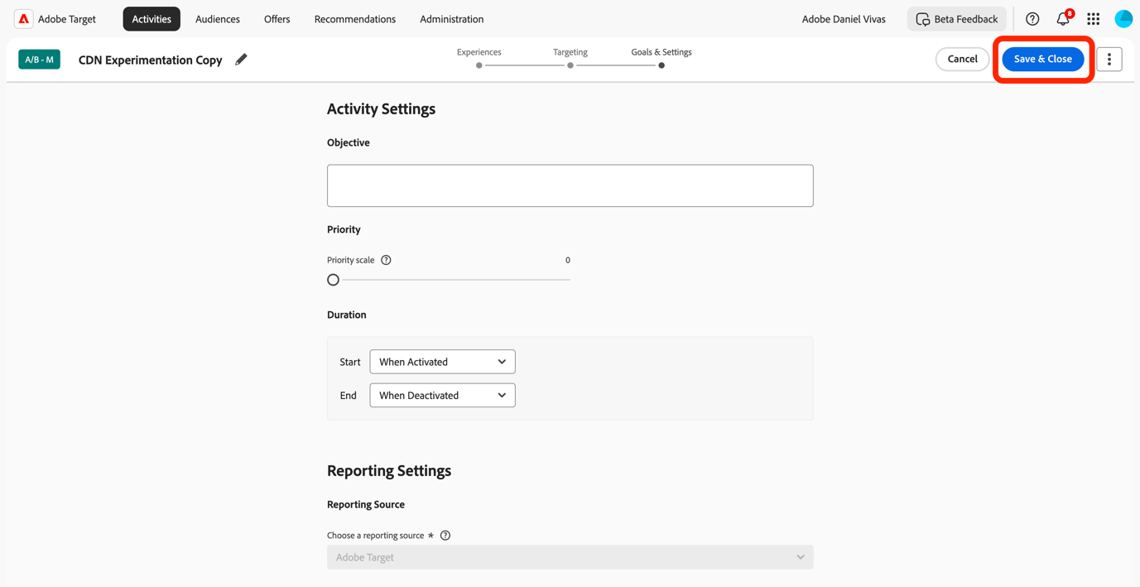

**Step 8:** Activate your Target activity

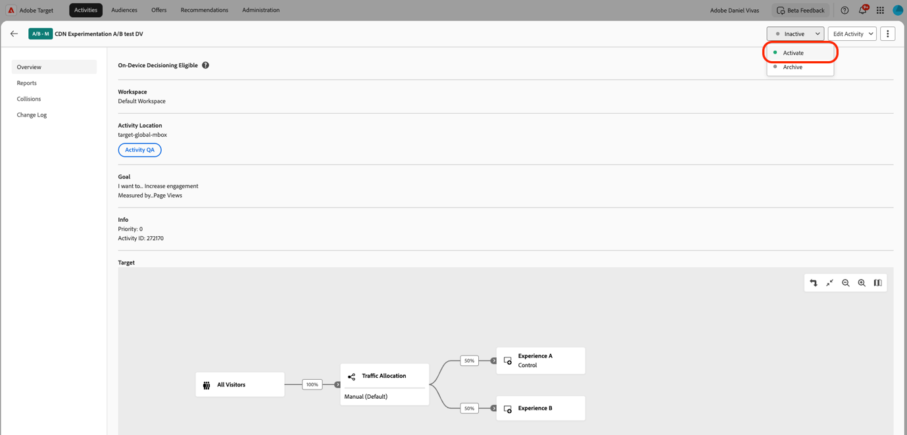

Part 2: CDN edge-worker CLI and CDN Property configuration

### Intro: CDN overview

Content Delivery Networks benefits:

* Distributed servers delivering web content based on user location.
* Reduces load times and improves performance by caching content globally.

Edge Computing aspects:

* Brings computation and data storage closer to data sources and users.
* Reduces latency, conserves bandwidth, and enhances user experience.

CDNs + Edge Computing key benefits:

* Real-time data processing and lower latency.
* Improved performance for dynamic content.

### Exercise 1: CDN CLI and CDN credentials

**This section contains steps related to configurations already available on the lab machines.**

**Section overview:** To be able to work with Akamai EdgeWorkers there are a few things that are required:

* Access to Akamai Control Center: <https://control.akamai.com/>
* Access to your organization group in Akamai
* A configured Property in Akamai
* Akamai CLI installed on development machine
* Akamai CLI for EdgeWorkers installed on development machine
* API Client credentials

### **Step 1 [preconfigured on the lab machines]:** Install Akamai CLI

1. Open your terminal.

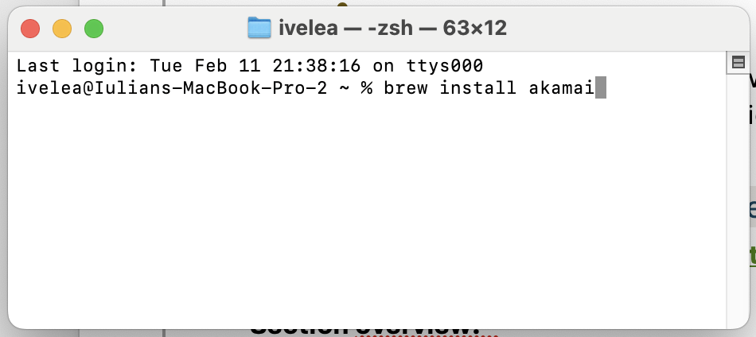

1. Run the following command to install Akamai CLI using Homebrew:

brew install akamai

### **Step 2:** Verify Akamai CLI Installation - To ensure Akamai CLI is installed properly, run:

akamai --version

This should print the Akamai CLI version, confirming the installation.

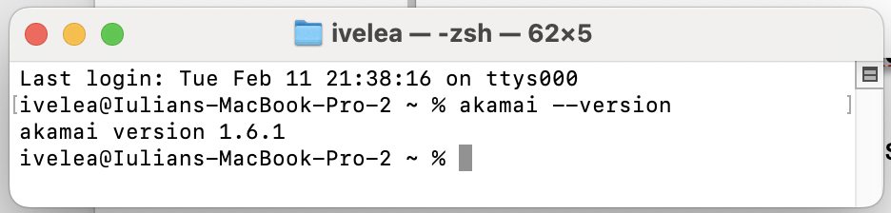

### **Step 3 [preconfigured on the lab machines]:** Install Akamai CLI for EdgeWorkers - Assuming Akamai CLI is installed, run the following command to install EdgeWorkers:

akamai install edgeworkers

### **Step 4:** Verify EdgeWorkers Installation **-** To ensure EdgeWorkers is installed properly, run:

akamai list

This should print a list of available Akamai CLI commands, including **"edgeworkers"**.

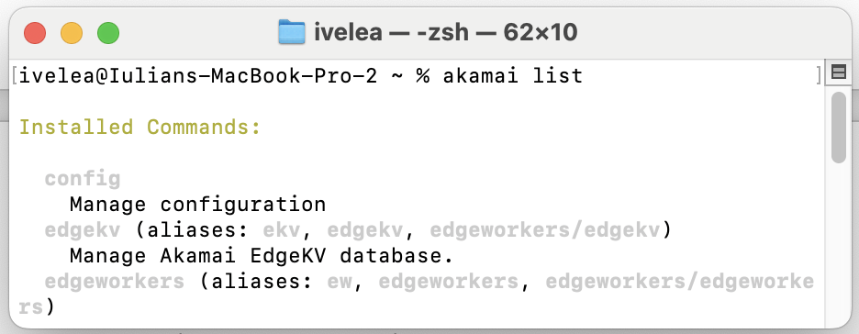

### **Step 5 [preconfigured on the lab machines]:** Create an API Client

1. Go to **control.akamai.com** and use the registered email address to sign in by clicking on the **“Next”** button.

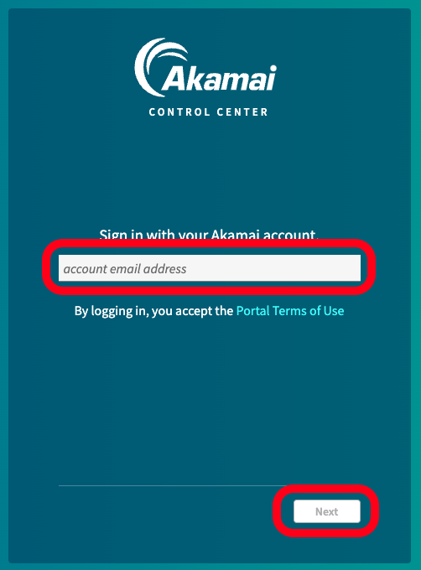

1. From the left navigation bar, go to **"Account Admin"**. Select **“Identity and Access”**.

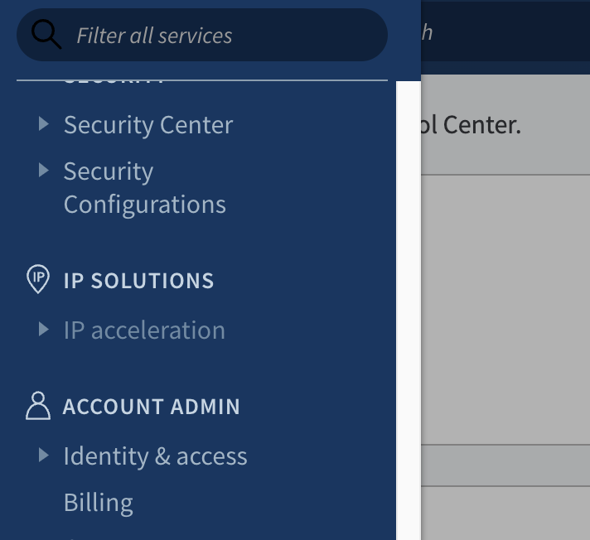

You should be redirected to the **"Users and API Clients"** tab.

1. On the **"Users and API Clients"** page, click **"Create API Client"**.

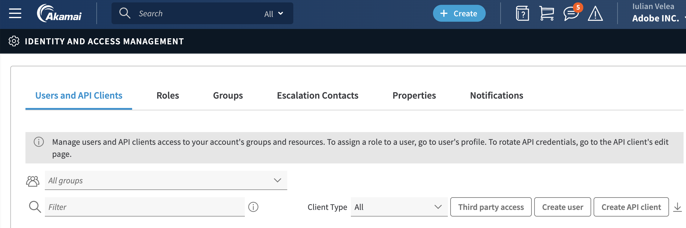

1. On the **"Create API Client"** page, select "**Myself"** and then click the **"Quick"** button. This will create an API Client with all your credentials. For a more restricted version, select **"Advanced"** and grant only the necessary permissions.

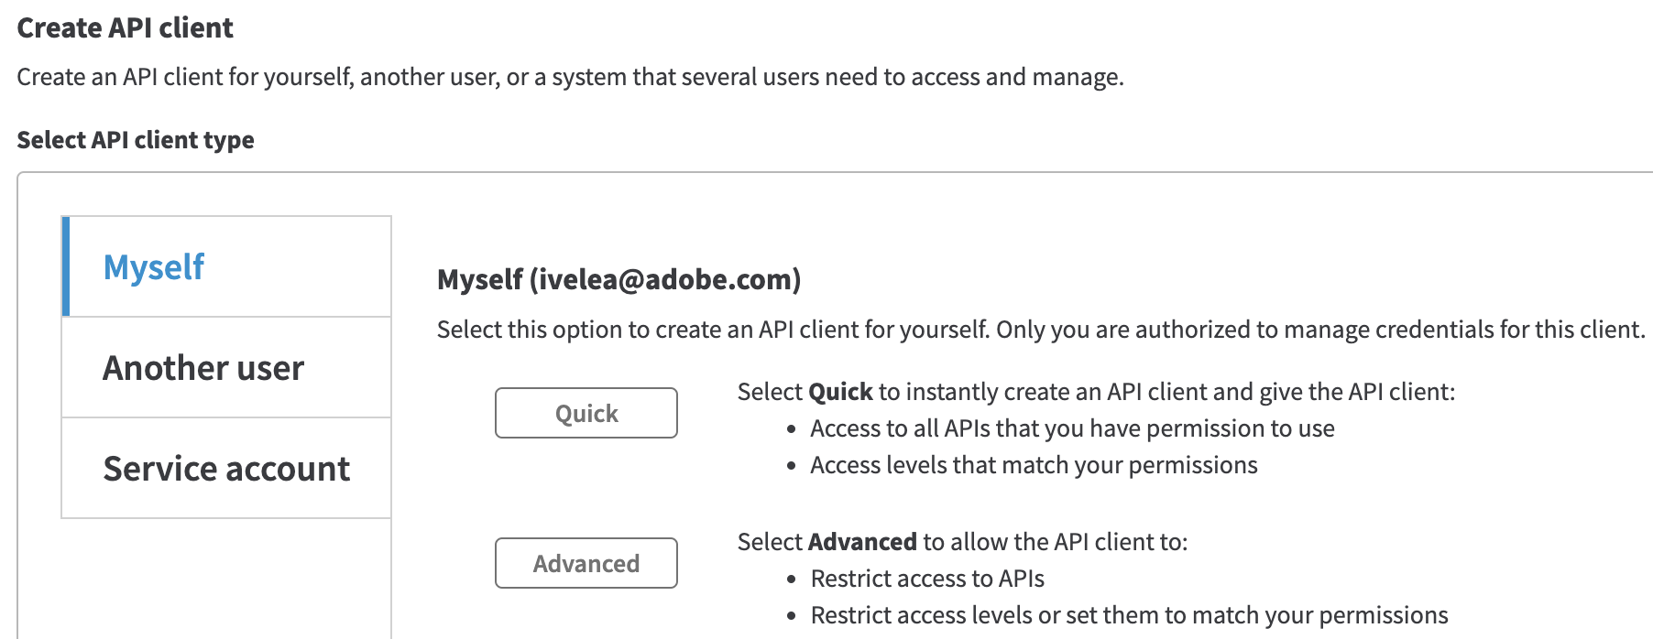

A new page named **"API Client for you"** will open.

1. On the **"API Client for you"** page, go to the bottom table and copy your credentials or create a new one.

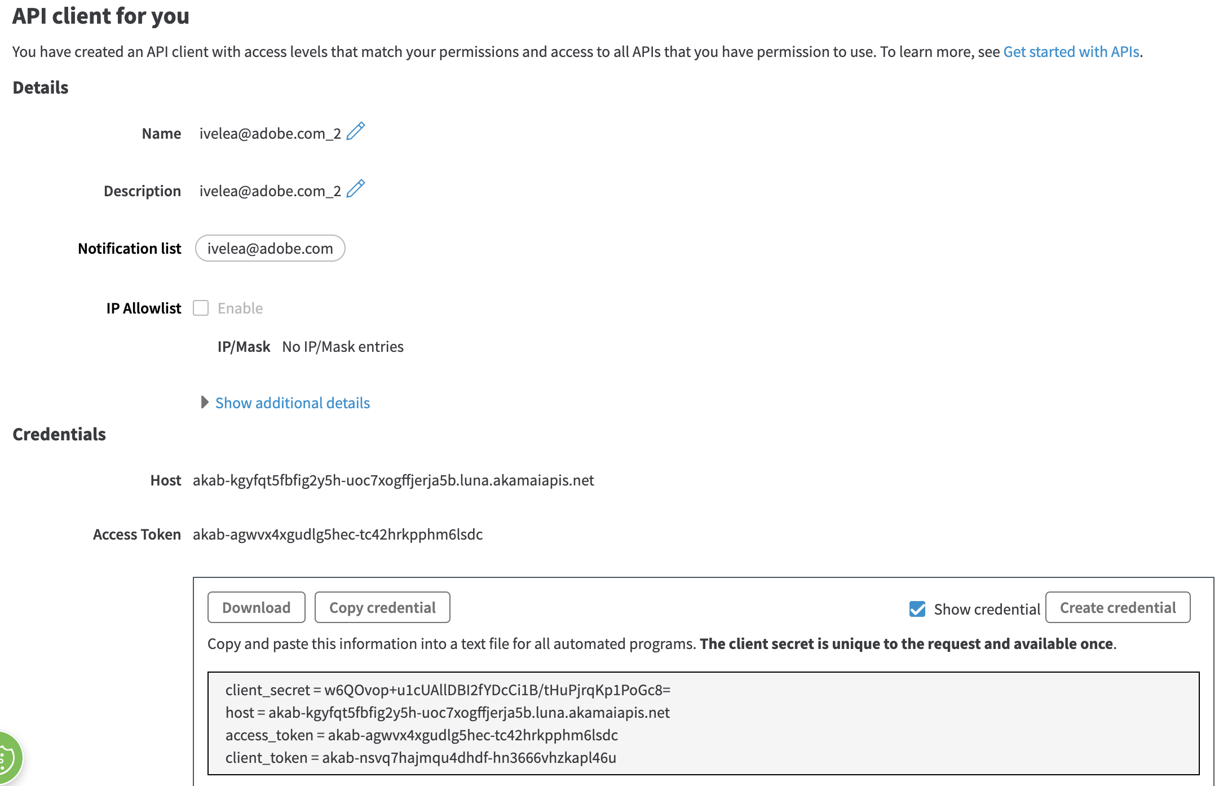

Make sure to copy the credentials and store them.

### **Step 6:** Check Credentials

1. Akamai CLI needs credentials to execute operations that might change the Akamai account state. These credentials should be stored in a special file named .edgerc.
2. On Mac OS X, the .edgerc file should be located at:

/Users/{username}/.edgerc

1. The **[default]** value should be placed as a header above all text in the **.edgerc** file to avoid errors. Check your local file by running the following command in your terminal:

cat /Users/ivelea/.edgerc

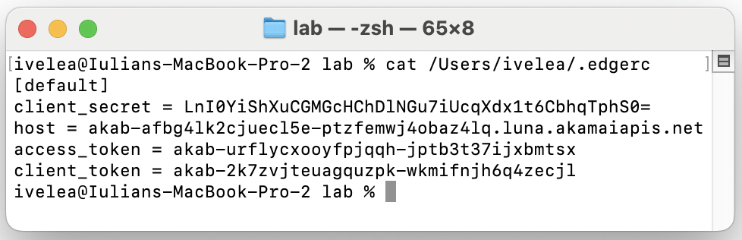

The file should look like this:

[default]

client_secret = ......

host = .....

access_token = ...

client_token = ...

### Exercise 2: CDN Property configuration (preconfigured for the lab)

**Step 1:** Log in to Akamai Control Center

1. Open your web browser and go to the Akamai Control Center: **control.akamai.com**
2. Enter your credentials to log in.

**Step 2:** Navigate to Property Manager

1. From the main dashboard, go to the left menu section.
2. Click on **"Properties"** under the **“CDN”** section.

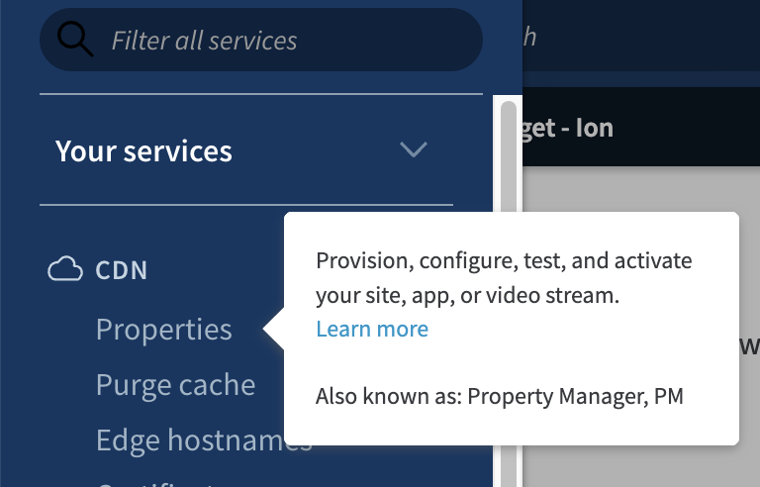

**Step 3:** Create a New Property

* In the Property Manager, click on the **"+New Property**" button.
* Select **“Ion Standard”** from the product list and click **“Create Property”**.
* The **“Set up Ion Standard”** page should be displayed

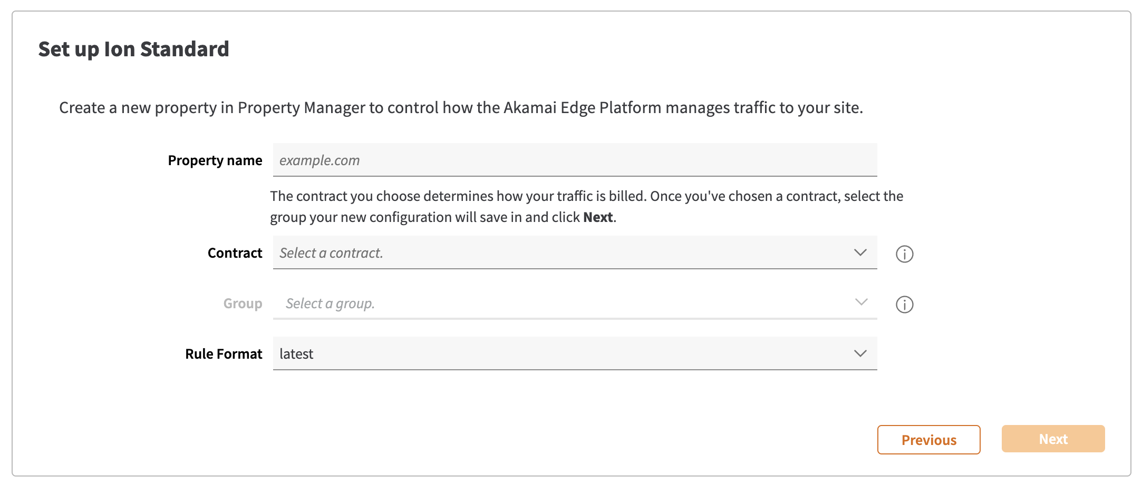

* In this page set a **“Property name”**, select the **“Contract”** for your organization and click on the **“Next”** button

**Step 4:** Configure Property Settings

* In the **Edit** property configuration page, you will see various settings and options.

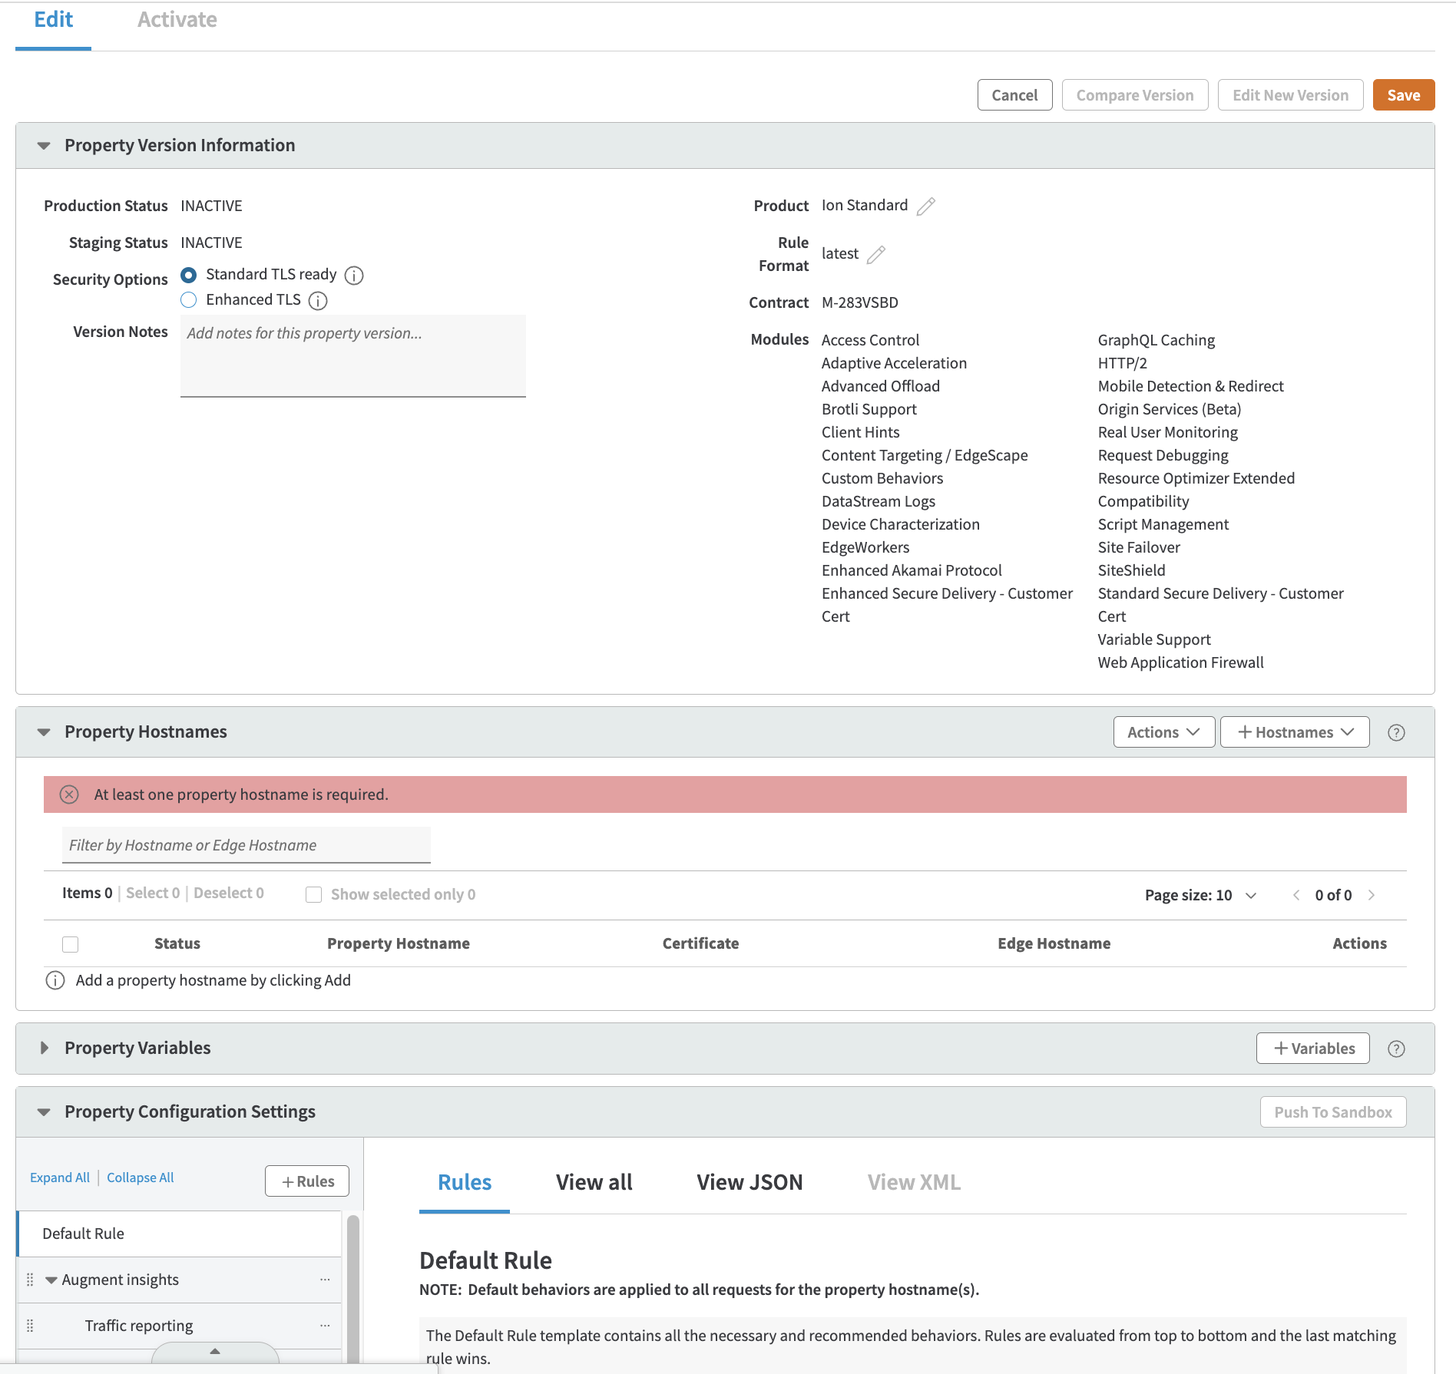

**Step 5:** Set up Hostnames

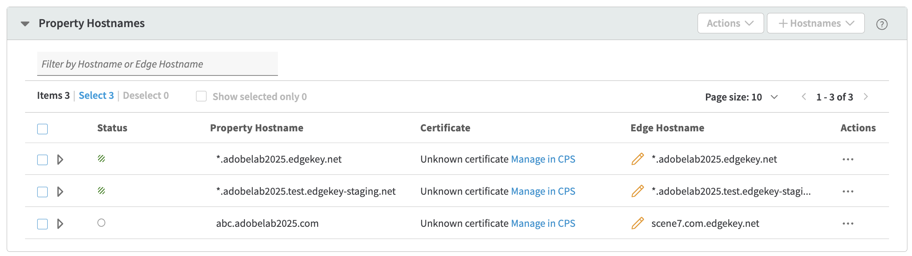

Hostnames section define the origin **Hostnames** URLs on which the Akamai Property applies, the associated **Certificates** and the **Edge Hostnames** corresponding to the origin hostnames. When defining hostnames wildcards are accepted.

You can add new Hostnames by clicking on the **“+Hostnames”** button.

**Step 6:** Set Up Rules and Behaviors

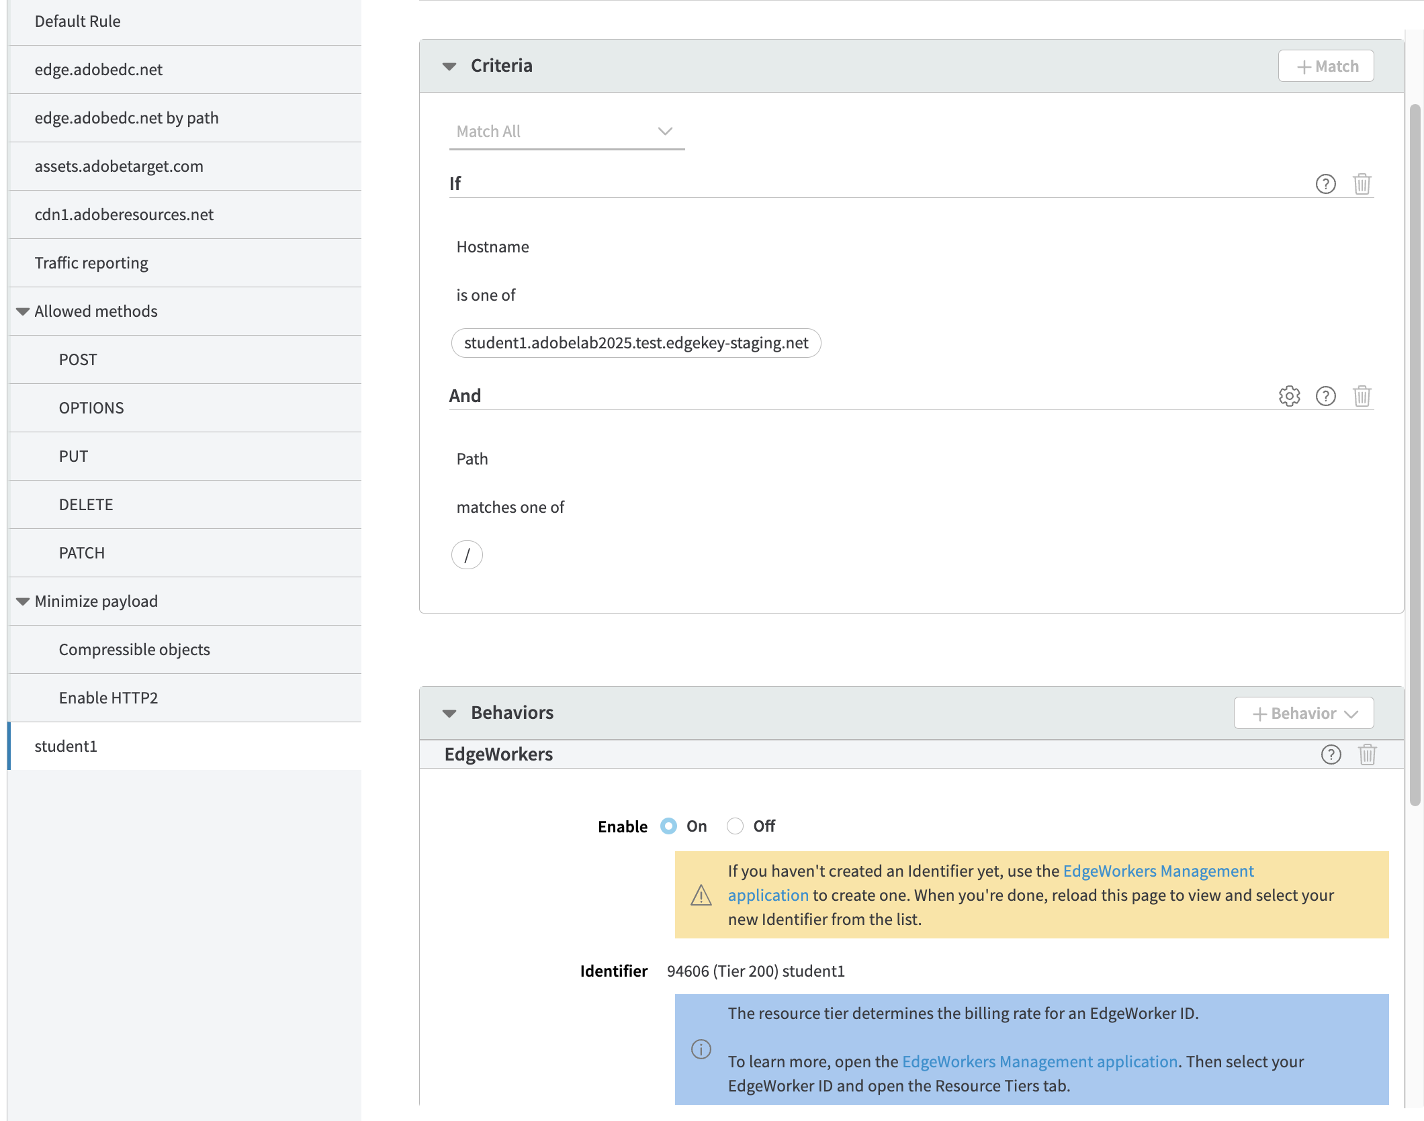

* In the Property configuration page, go to the "**Property Configuration**" section. In here you can define the Behavior of the property by adding **Rules**, configuring **Criteria** and **Behaviors** for each rule.
* When a request is received by the CDN Edge nodes, the rules are evaluated sequentially, and the most specific rule will be the one applied.
* If you want to add a new **Rule** you need to click on the **“+Rule”** button from the left panel.
* In the **Criteria** section you can define the conditions which are evaluated for each **Rule**. The **Condition** is a Boolean expression.
* In the **Behaviors** section you can define the behavior when a Rule has been selected to be applied.
* In the above example when the requested URL hostname matches the value student1.adobelab2025.test.edgekey-staging.net and the path is “/” then the **“student1”** rule will be selected. In this case the Behavior is to route the request to the EdgeWorker having the ID equal with **94606**.
* Click **"Save"** to persist the configuration of the **Property**.

**Step 7:** Activate the Property

* Once you have configured all the necessary settings, when you get back to the **Property Details** page you will see a new version being available. Click on the **"Activate"** button from the contextual menu.

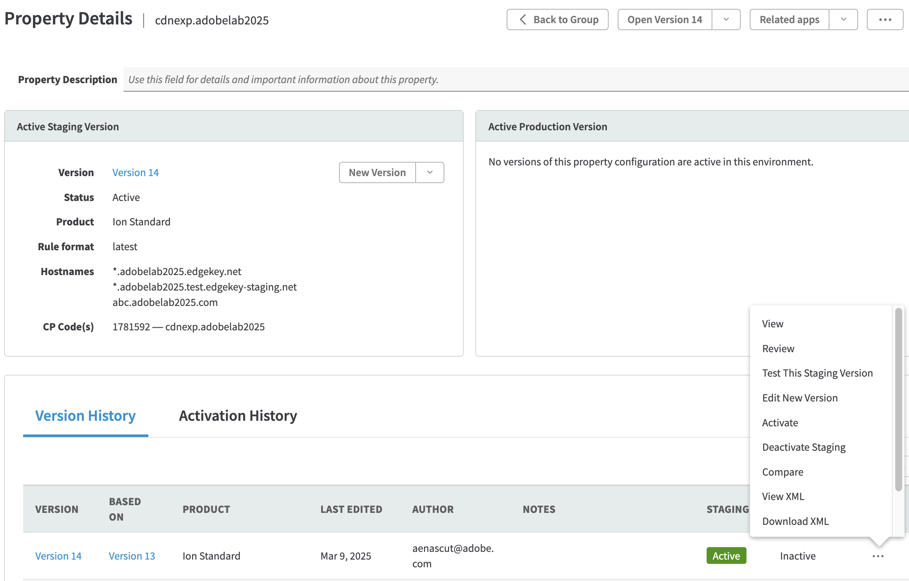

* Select the environment (e.g., **Staging** or **Production**) where you want to activate the property.
* Review the configuration and click "**Activate vxx on Production"** to deploy the new Property version.

**Step 8:** Test the Configuration

* After activation, test the configuration by accessing the external URL through your Akamai property.



* Ensure that the requests are properly routed, and that the external URL is accessible.

## Part 3: Coding with CDN Experimentation SDK

Overview of CDN Experimentation Solution:

1. The visitor accesses the website, initiating a request to the CDN edge.
2. The rules package is either fetched or supplied.
3. The HTML page is retrieved from the origin.
4. The rules are assessed to determine the outcomes.
5. Consequences are applied.
6. Personalized page is displayed
7. Event reports are dispatched.

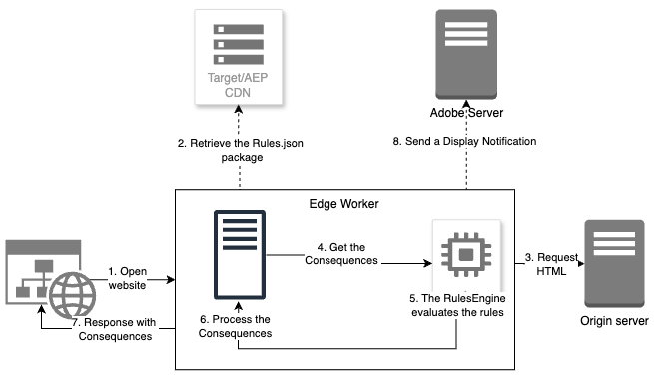

### Exercise 1: Open the Lab Project in the IDE

**Step 1:** Open the **Visual Studio Code** IDE 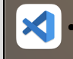

**Step 2:** From the Menu bar select **File/Open Folder** action

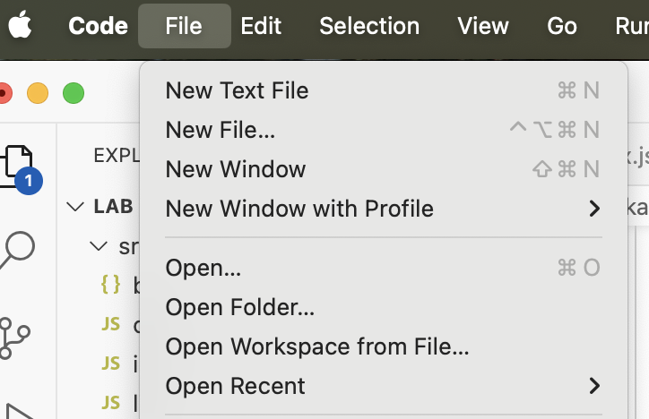

**Step 3:** From the **Desktop** folder select the **lab** subfolder containing the lab code

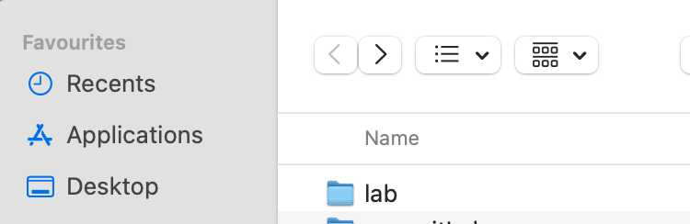

You should see the following project structure in VS Code **Explorer** window:

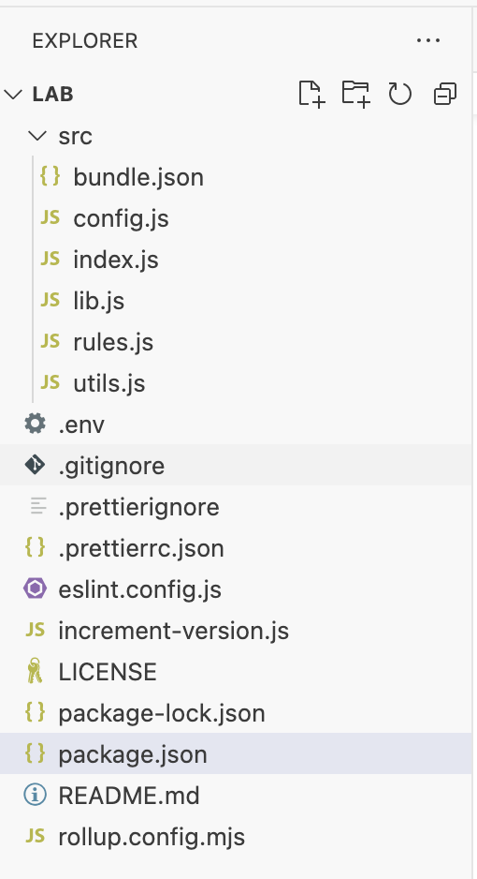

**Step 4:** Click on the **index.js** file to open it in the Editor pane.

EdgeWorker execution process:

1. The SDK Client is set up and configured (for example, with the rules bundle CDN address).
2. It fetches and stores the rules package.
3. The **rules** are then assessed, and the applicable **consequences** are determined.
4. These consequences are transformed into a response compatible with AEP Web SDK.
5. Based on this response, the SDK user can decide whether to apply it (using *html-rewriter*), integrate it into the HTML page, or utilize it for other personalization needs.
6. The SDK user has the option to notify the Adobe Edge Network once the response has been ”consumed" (to ensure accurate metric tracking).

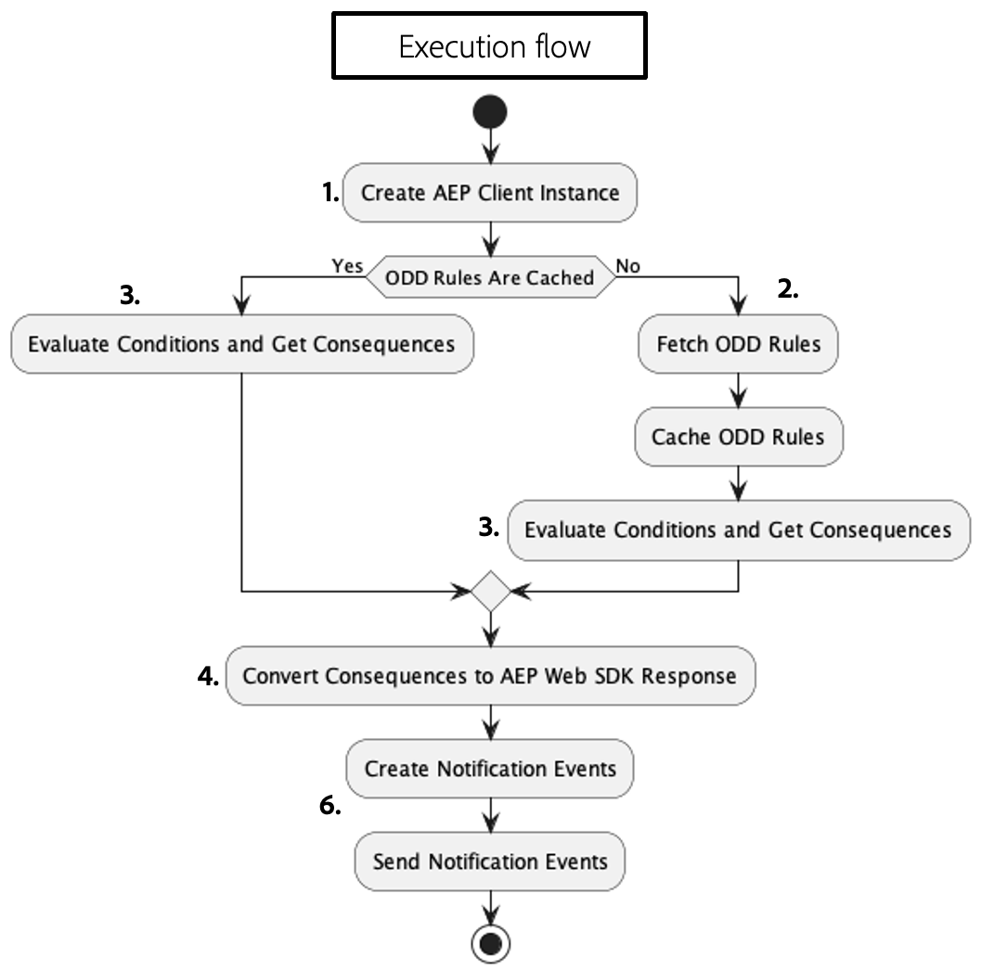

### Exercise 2: Creating the CDN Experimentation SDK Client Instance

The following snippet demonstrates the instantiation of the CDN Experimentation client with the specified arguments:

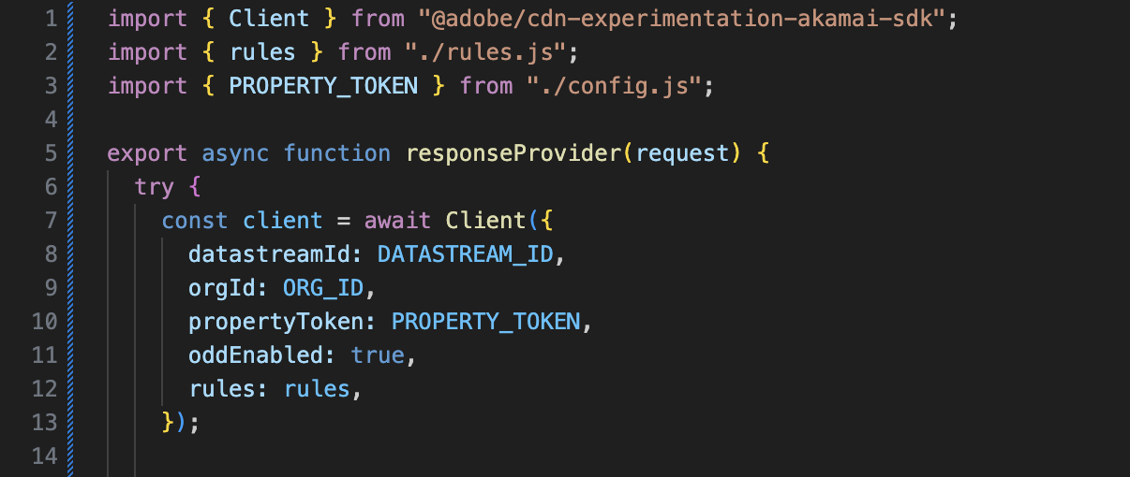

**Step 1:** Into the **index.js** file add the following lines of code, inside the responseProvider

function, to create and configure the SDK client:

const client = await Client({

orgId: "82C94E025B2385B40A495E2C@AdobeOrg",

datastreamId: "bdb5cb8a-4496-4abd-8afc-e9396c1b1c27",

propertyToken: "",

oddEnabled: true,

edgeDomain: "abc.adobelab2025.com",

});

**Step 2: orgId**: it represents the IMS Organization Id.

To retrieve the IMS Organisation Id you need to navigate to the Adobe Target – **Administration / Implementation** section, **Account details,** select and copy the value for the org Id:

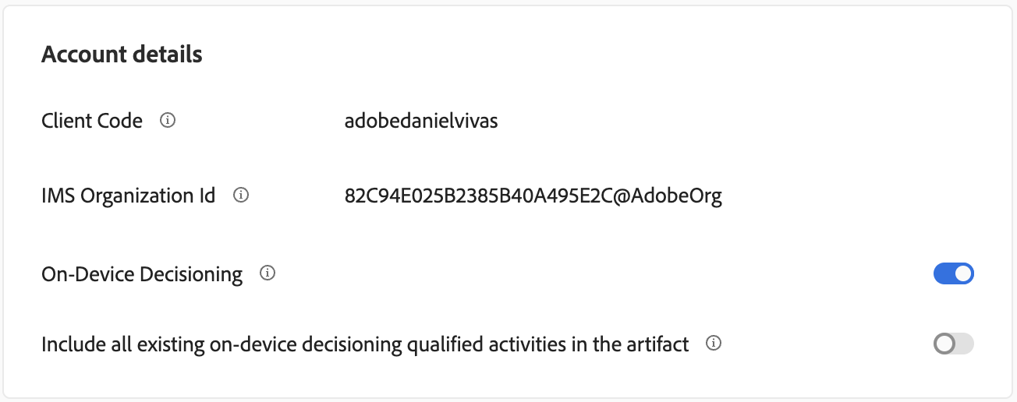

**The copied value should be set as the value for the orgId parameter in the previous code snippet. In the case of the lab exercise the orgId is:** 82C94E025B2385B40A495E2C@AdobeOrg

**Step 3: datastreamId**: the datastreamId from the Adobe Experience Platform – [Datastream section.](https://experienceleague.adobe.com/en/docs/experience-platform/datastreams/configure#view-details) connected to Adobe Target (e.g.bdb5cb8a-4496-4abd-8afc-e9396c1b1c27).

***Step 3.1:*** Navigate back to the **Adobe Experience Cloud Home** page and select **Experience Platform** solution from the **Quick Access** panel:

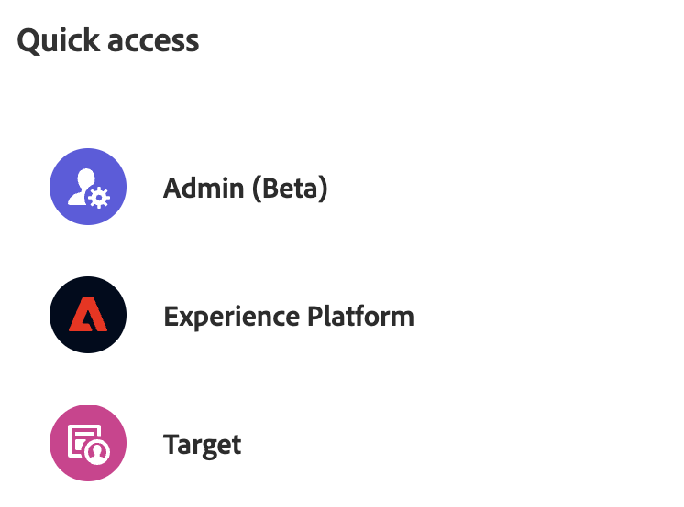

***Step 3.2:*** Select the **Datastreams** section from the left Panel and then, in the right **Datastreams** list click on the **“Copy to clipboard”** button associated with the datastream we want to use, to copy its **datastreamId**:

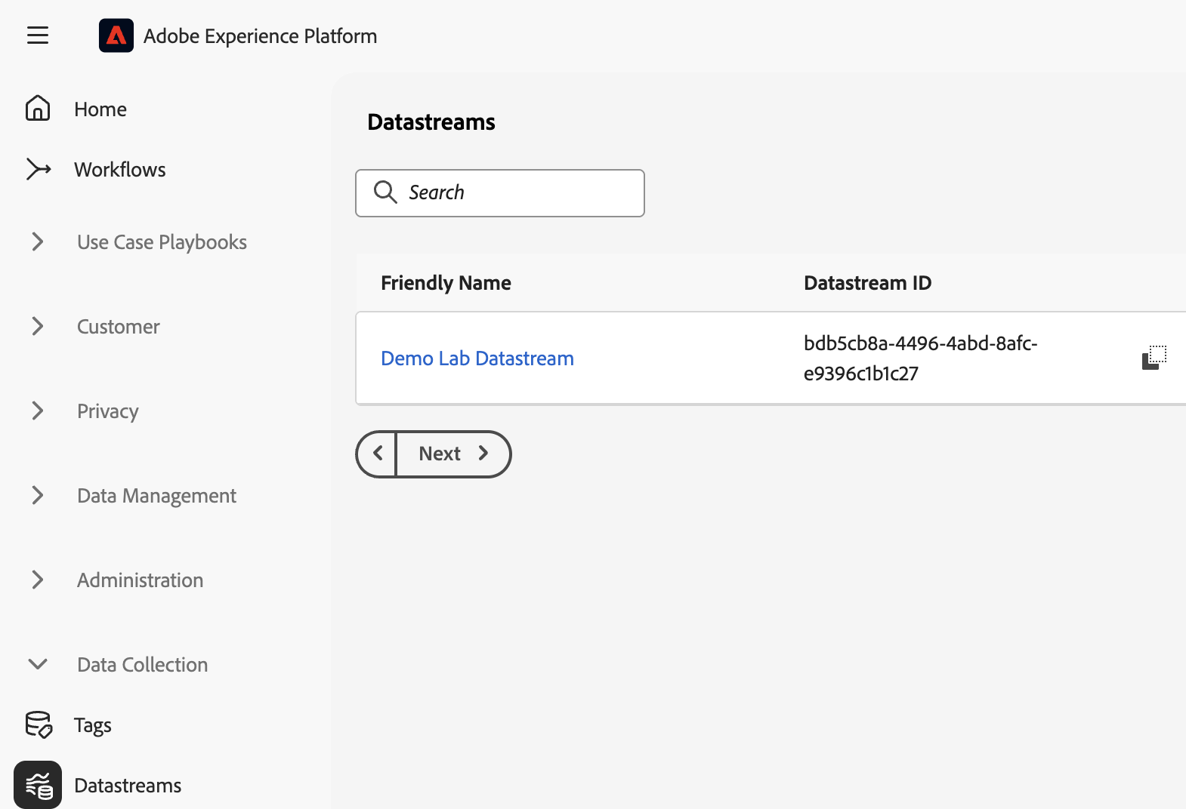

**The copied value should be set as the value for the datastreamId parameter in the previous code snippet.**

**Step 4: propertyToken**: [Adobe Target property token](https://experienceleague.adobe.com/en/docs/platform-learn/implement-web-sdk/applications-setup/setup-target#property-token) associated with the activity used to reduce the bundle size by selecting only the activities associated with it.

***Step 4.1:*** To retrieve the **propertyToken** you need to navigate to the **Adobe Target** **Administration** page, **Properties** section.

Locate your property associated with the seat number (e.g. L537-seat01) and click on the **Code button** (</> icon):

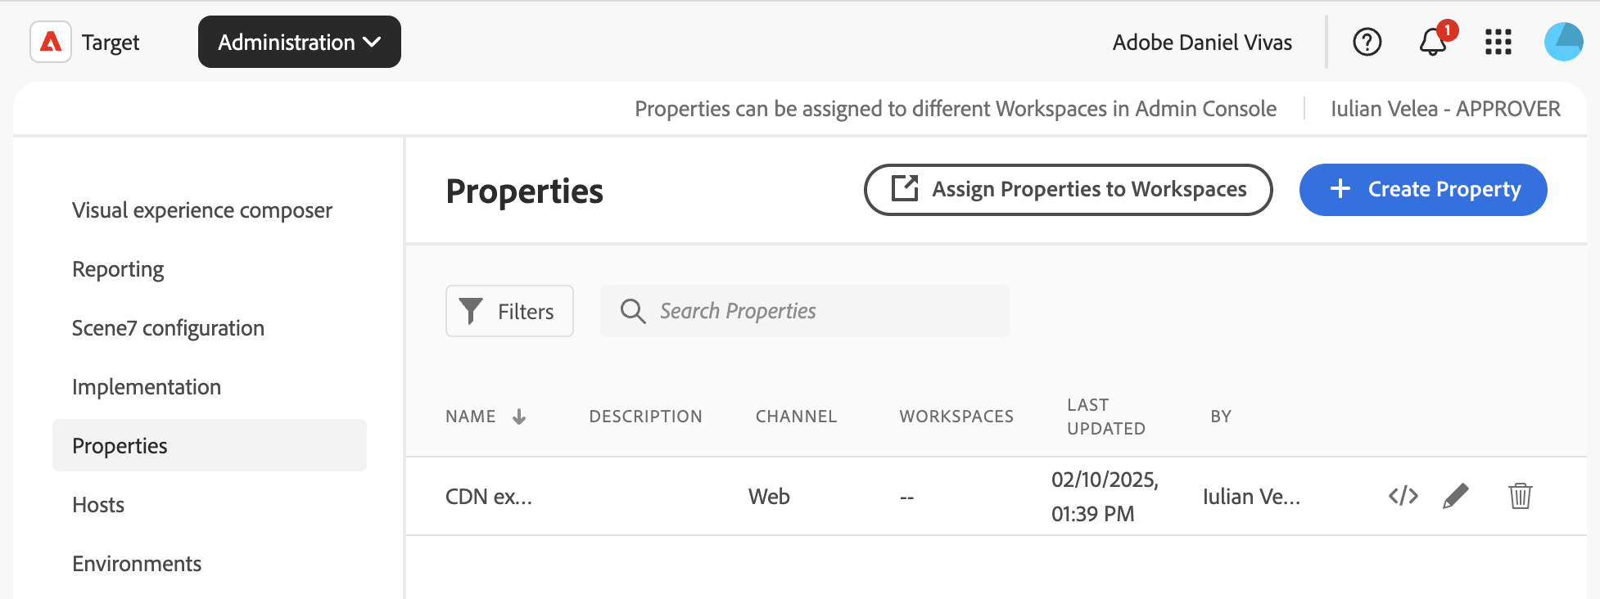

***Step 4.2:*** From the **Code** dialog select and copy the property token value: **Todo**

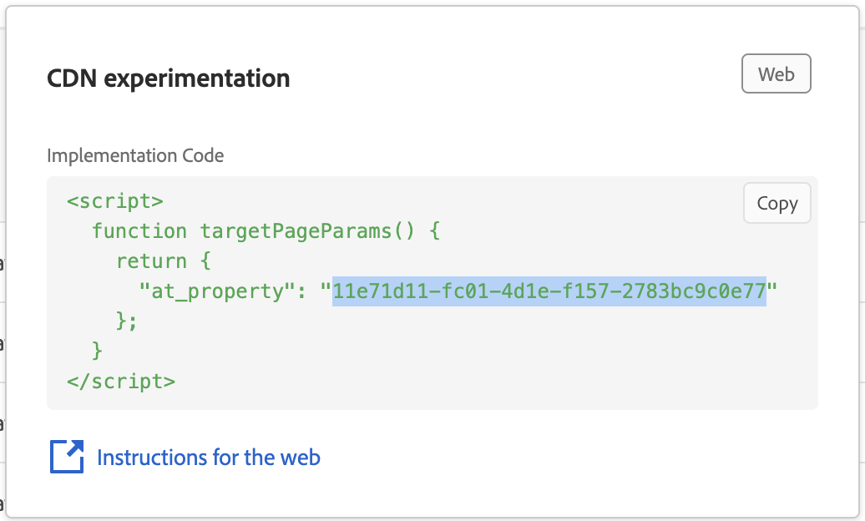

**The copied value should be set as the value for the propertyToken parameter in the previous code snippet.**

**Step 5: oddEnabled**: true/false;

* + **true** – will do the decisioning inside the edge worker.
  + **false –** the library will act as a proxy to the Adobe API and call the */interact* endpoints for each decision request. No local decisioning is made.

**For the lab exercise oddEnabled parameter value needs to be set to true.**

**Step 5 [not required]: rules**: object containing the rules retrieved from the Adobe servers in AEP format. The rules can be retrieved by the developer and passed to the SDK client as a configuration parameter. If the rules are not provided, the SDK Client will retrieve them from the Adobe servers.

**For the lab exercise the rules bundle will be automatically fetched.**

Evaluation and preparation of the rules

The **SDK** **Client** will return an object that contains the rules ready for evaluation and execution. If there is any problem the **Client** will throw an error.

The types of errors that can appear can be related to

* the library not being able to fetch the rules (might be a configuration problem in Akamai)
* the rules are not in the correct format
* the configuration Id’s are missing or incorrect
* ...other problems

### Exercise 3: Retrieving the consequences

Upon receiving a client request, the SDK will assess the request and determine the implications. The **Event** must be built on the EdgeWorker [in the XDM format](https://experienceleague.adobe.com/en/docs/experience-platform/web-sdk/use-cases/top-bottom-page-events#spa-example).

In the code sequence below, we are constructing an event that enables decision-making based on the visitor allocation to the available Experiences, using the ECID cookie value, and the URL, by passing in the address.

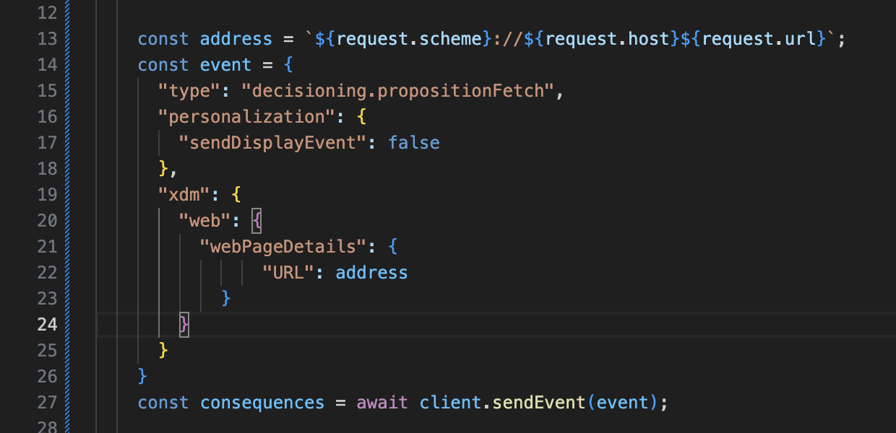

**Step 1:** The **client.sendEvent** function will receive the **event** and respond with the consequences.

In the **index.js** file go to the section where the event is created and add the following line of code to retrieve the consequences:

const consequences = await client.sendEvent(event);

### Exercise 4: Sending the Display event

**Step 1:** To track displayed events, we need to send a notification to Adobe servers. Typically, this can be done in a fire-and-forget manner, as the result is not needed.

Set **“sendDisplayEvent: true”** in the **event** passed to the **sendEvent** function to let the library automatically send the event.

### Exercise 5: Working with the consequences

The consequences provided by the **client.sendEvent** function can be applied in the Edgeworkers code for A/B testing the origin website.

In the following code example, we are using the **HtmlRewritingStream**, extracting the consequence items, and applying the content of the consequence on the Origin response stream.

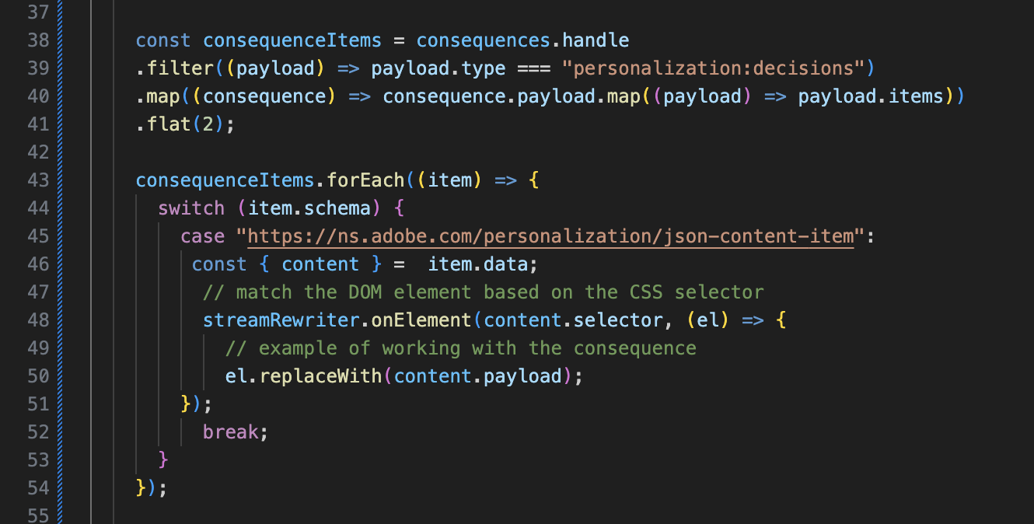

**Step1:** Go to the line// Exercise 5. Apply the consequences to the origin stream

and add the following lines of code to instantiate the **HTMLRewritingStream**

const streamRewriter = new HtmlRewritingStream();

**Step 2:** Go to the **forEach** loop in the **index.js** file and, after the line containing the comment // match the DOM element based on the CSS selector, add the following code sequence:

streamRewriter.onElement(proposition.selector, (el) => {

el.replaceWith(proposition.payload);

});

Exercise 6: Returning the processed response

After creating the HTML rewriter processing stream, we need to return the Response to the client and the EdgeWorker code will apply the changes on the returned page.

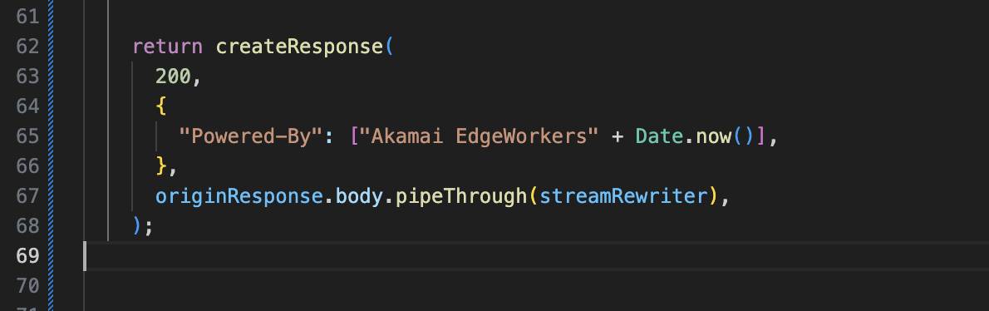

**Step 1:** In the **index.js** file go before the line marking the end of the **catch** block and add the following code snippet:

return createResponse(

200,

{

"Powered-By": ["Akamai EdgeWorkers " + new Date().toString()],

},

originResponse.body.pipeThrough(streamRewriter),

);

Exercise 7: Deploy your code to the EdgeWorker

**Step 1:** Set the EdgeWorker ID

Open the **.env** file in the IDE and add the **EdgeWorker ID** provided for your seating number (e.g. 94606) as the value for the EDGEWORKER_ID variable:

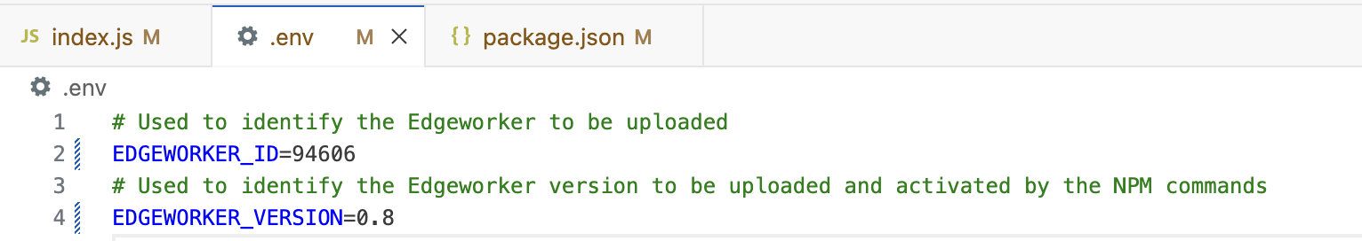

Leave the EDGEWORKER_VERSION unchanged as this will automatically be update during the **prebuild** step.

**Step 2:** Build your project

In the Visual Studio Code left navigation panel select the **package.json** file, go to the **scripts** section, and run the **“build”** script:

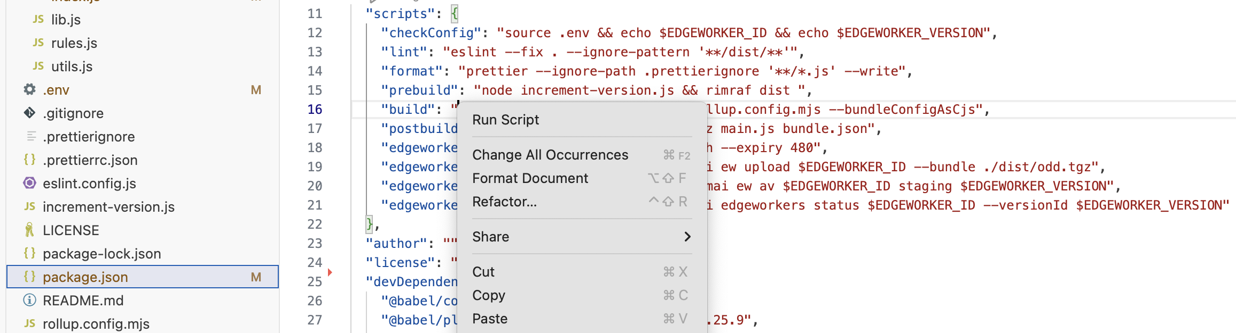

There should be no errors reported in the terminal:

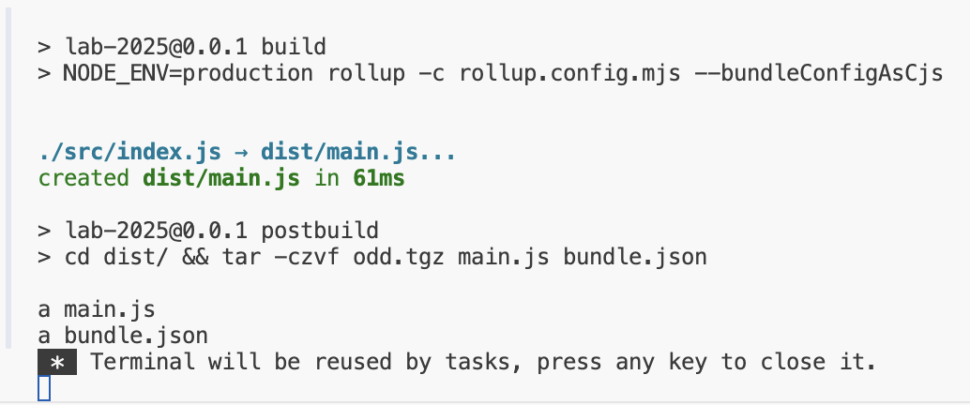

**Step 3:** Deploy your code

From the **package.json** file go to the line with the **“edgeworker:deploy”** script and run it. If the deploy is succesful you should see the following message in the terminal window:

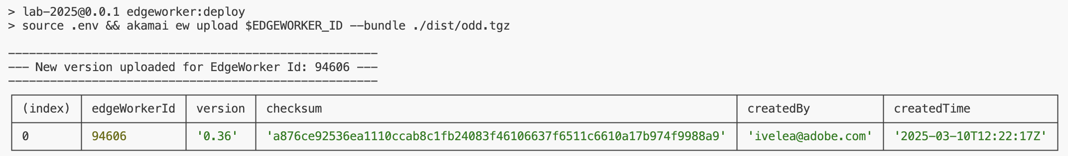

**Step 4:** Activate your deployment

From the **package.json** file go to the line with the **"edgeworker:activate"** script and run it in order to activate the new package deployed on the EdgeWorker.

For checking the status of the deployment you can run the **“edgeworker:status”** script.

After the activation has been completed, this command should display in the terminal panel the **Complete** value in the **status** column. This usually takes a couple of minutes depending on the size of the new build package:

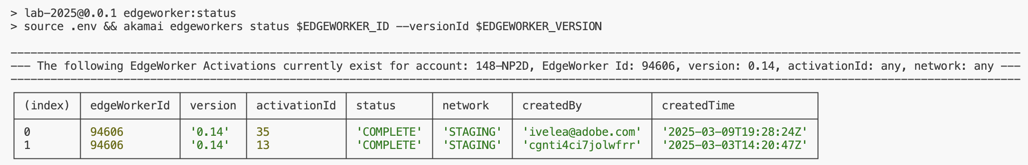

Exercise 8: Test your new deployment

**Step 1:** Test the newly activated code package

Open a new Browser Tab and enter the ***seatXX***.adobelab2025.test.edgekey-staging.net value in the address bar, depending on your seat number.

The page should be loaded and the result of the EdgeWorker processing should be embedded in the displayed version. Depending on the performed user allocation, you should be served with the result of applying Experience A or Experience B defined in the Target Activity.

To get the result of the other Experience you can open a new Incognito browser window and access the same URL.

Additional steps:   
Exercise 9: Persisting the ECID cookie value

Adobe Target identifies unique visitors based on the ECID value that it’s generated in the server. The ECID value provides a stable Experience selection and reporting.

The ECID value need to be persisted in the browser for each visitor in Cookies.

When the requests arrive from the browser we will see if the ECID cookie is present and add it to the Event object used for deciding the Experience.

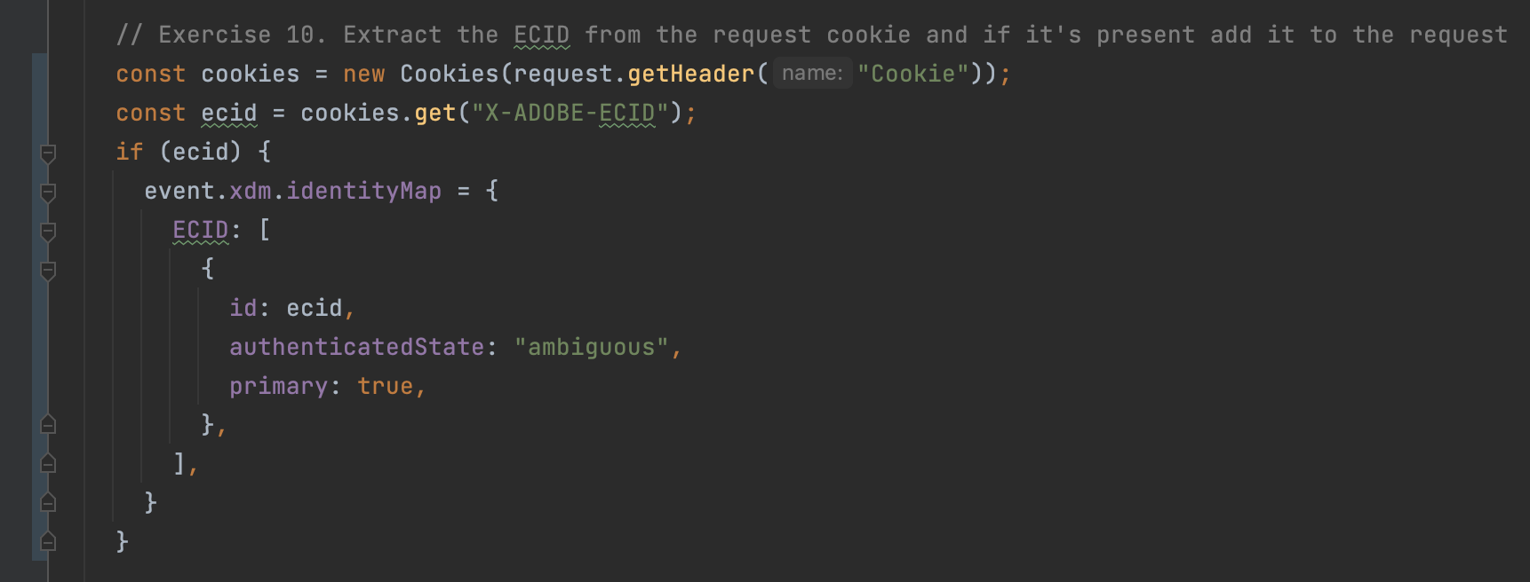

When returning the response, we make sure that the ECID cookie is set so that we persist it across the sessions.

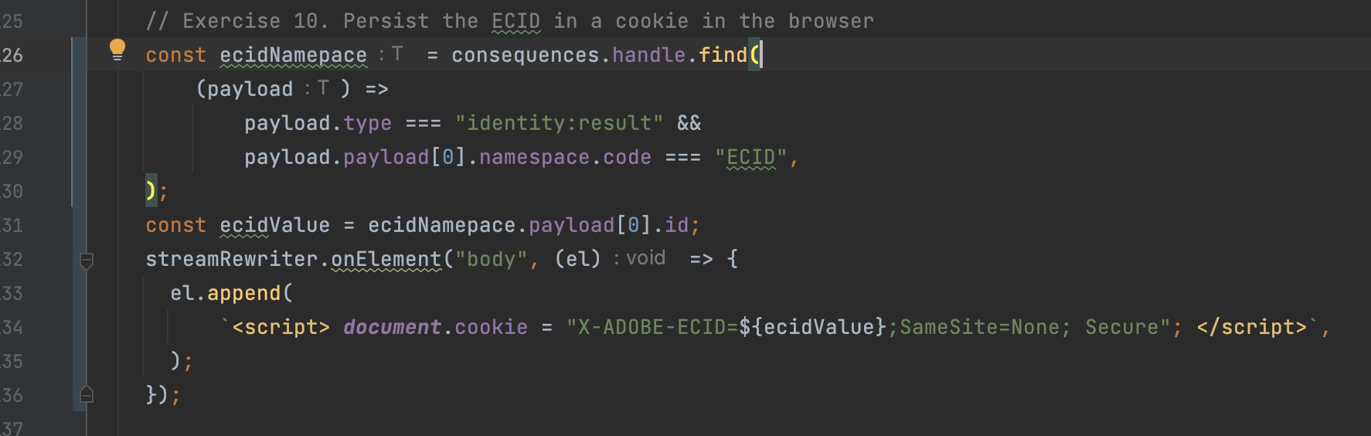

Additional steps:   
Exercise 10: Debugging your new deployment

Akamai Edgeworkers communicate the log messages through the response headers attached to the response. To activate the debug functionality, we need to set two headers to be sent along with the webpage request inside the ModHeader chrome extension.

Step 1) Inside Google Chrome find the ModHeader extension

Step 2) The **Pragma** header specifies the type of logs and debug information that will be returned. For the Lab set the header name Pragma and the value the following list:

*akamai-x-ew-debug, akamai-x-ew-debug-rp, akamai-x-ew-debug-subs, akamai-x-ew-subworkers*

For a reference of values please see [the Akamai documentation](https://techdocs.akamai.com/edgeworkers/docs/enable-standard-debug-headers)

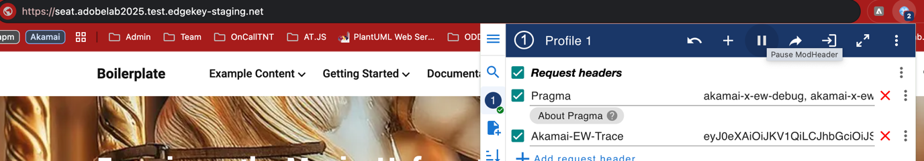

Step 3) Go to the proejct and run the command “**edgeworker:auth**” from the **package.json** file. This will provide you with an authentication token. Copy paste just the token value highlighted in the screenshot below.

Step 4) Go to Google Chrome and open the ModHeader extension. Set the Header name **Akamai-EW-Trace** and the value copied from the console in step 3. This will allow the Edgeworker to output the log in the response headers.

Copy paste the token the red border inside the ModHeader chrome extension.

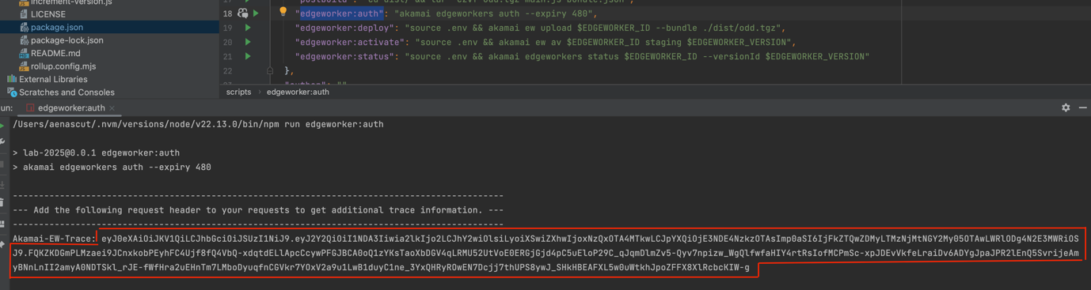

## Appendix

### Edge worker runtime environment limitations

* + <https://techdocs.akamai.com/edgeworkers/docs/resource-tier-limitations>

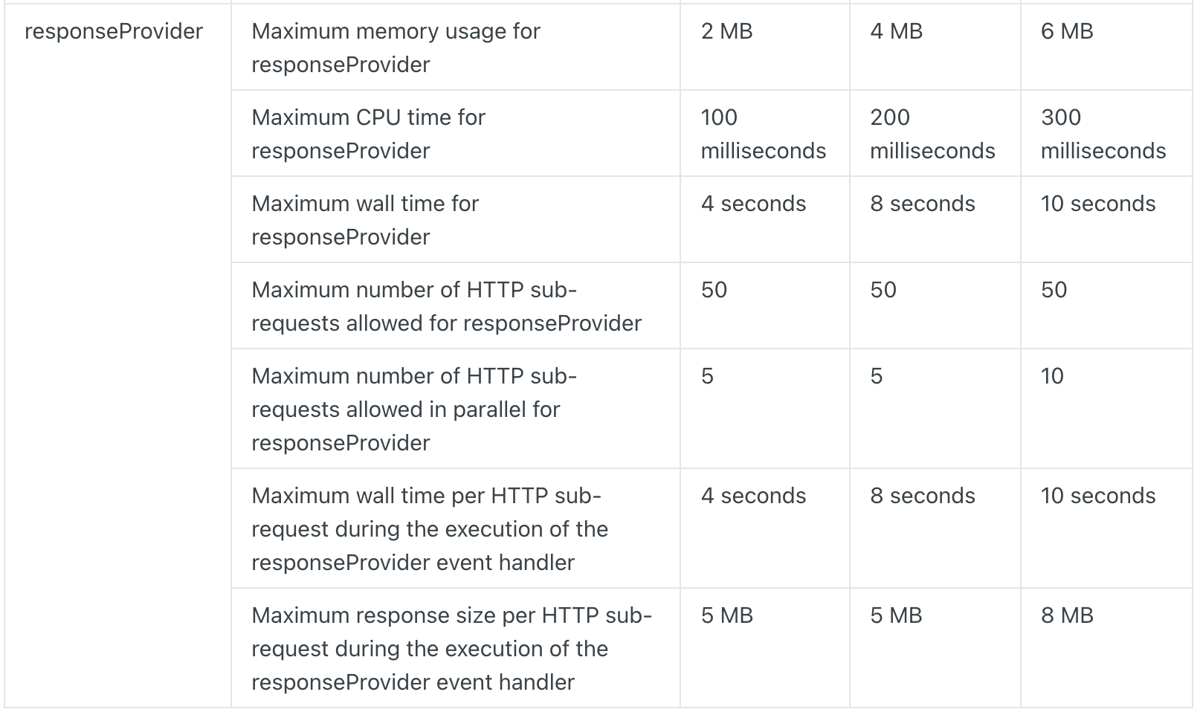

* + <https://techdocs.akamai.com/edgeworkers/docs/limitations>

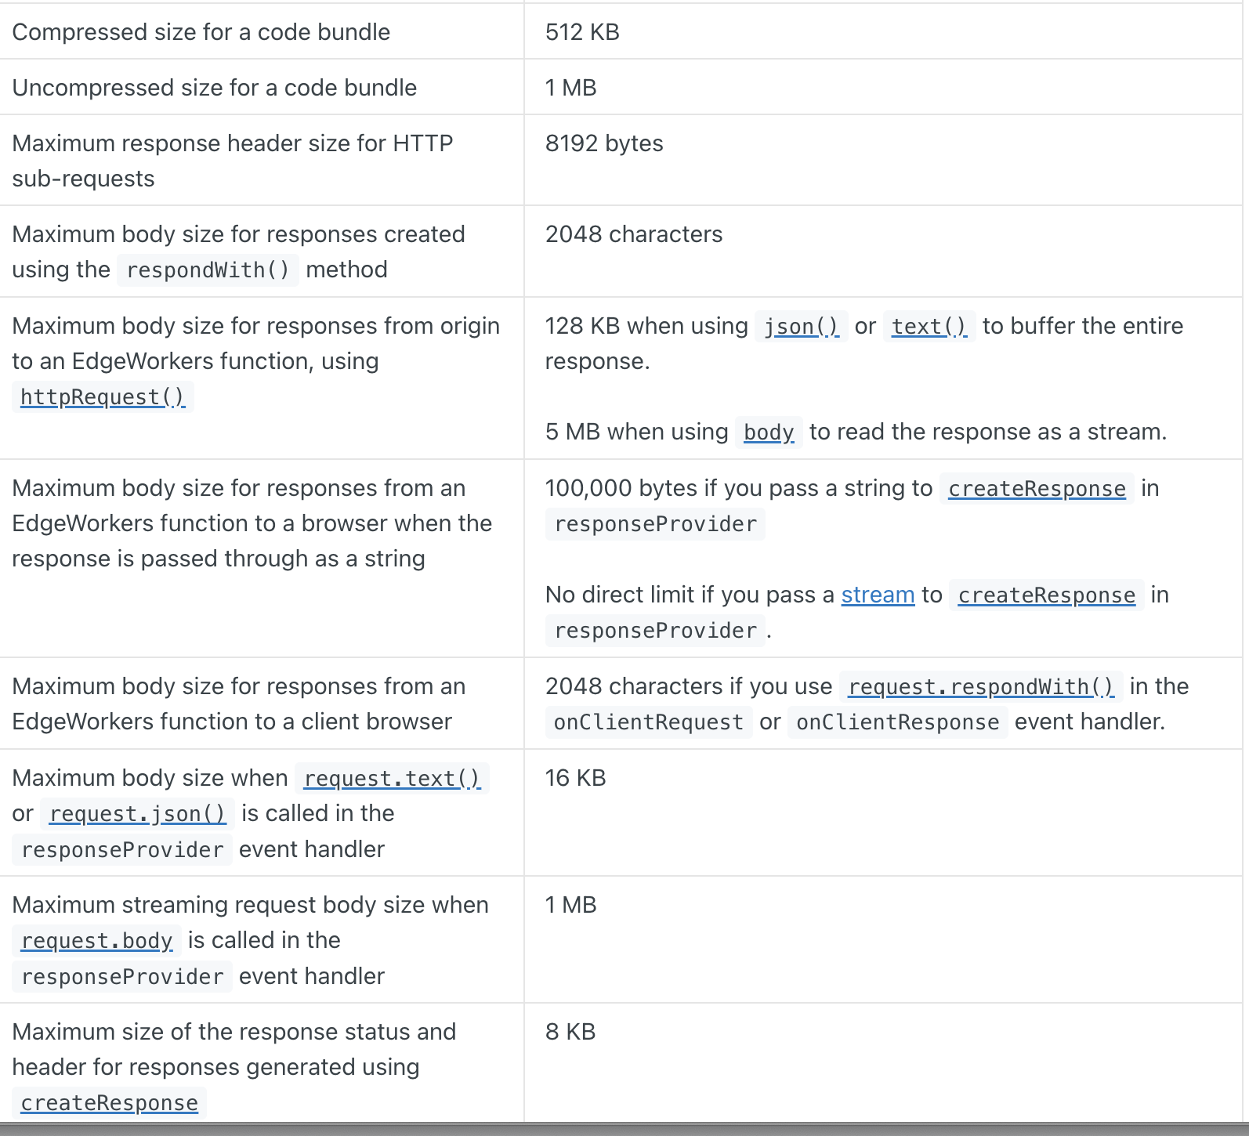

Workflow for the rules package:

1. A user of Adobe Target creates **Activities**.
2. The rules package is uploaded to an AWS S3 bucket.
3. Content from the S3 bucket is delivered through a CDN.
4. The rules package is accessible for download via the [**adobe.io**](http://adobe.io/) API.

